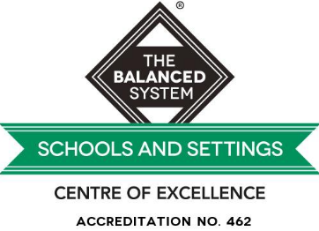
Speech and Language
The Balanced System

Supporting speech language and communication at Kingsdown School
Speech, language and communication are essential life skills. They are linked to learning, attainment, behaviour, social and emotional development, and mental wellbeing.
The Balanced System® is used in Southend to help everyone work together to support pupils’ speech, language and communication, and this includes us working in a more joined up-way with the speech and language therapy service.
We have three allocated speech and language therapists from the NHS who work with individual pupils.
We commission ChattyBoxx a private Speech and Language service to support our pupils at Kingsdown, they work 2 days a week at Kingsdown supporting individuals and groups work towards their SaLT goals.
Each term Communication Leads, NHS SaLT and ChattyBoxx meet to help plan and improve support for speech, language and communication across the school.
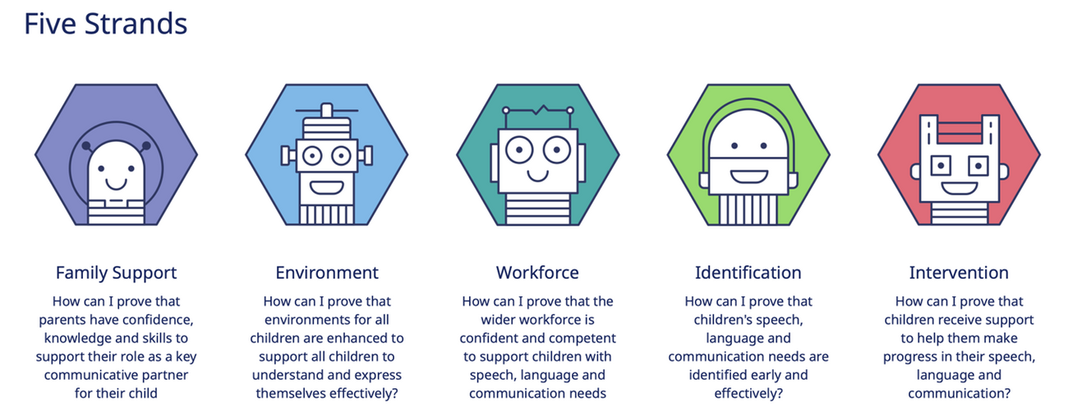
Our school is committed to achieving the following outcomes, known as the ‘Five Strands’ of the Balanced System®:
- Family support: Parents have the confidence, knowledge, and skills to support their child's speech, language and communication; and pupils can make pro-active choices about their support.
- Environment: classrooms and other places in school are set up to help pupils to understand and express themselves effectively.
- Workforce development: our staff know how to support pupils with their speech, language and communication.
- Identification: speech, language and communication needs are identified early and effectively.
- Intervention: pupils get the help they need to make progress with their speech, language and communication.

In each strand, there are three levels of support:
- Universal Support: Helps all pupils with speech, language and communication. For example, staff using visual aids to enhance understanding in class.
- Targeted Support: Assists pupils with speech, language and communication needs (SLCN) or those at risk. For example, pre-teaching vocabulary and small language groups.
- Specialist Support: For more complex SLCN requiring individualised approaches. For example, therapy for a child with a complex speech sound disorder.
Pupils may need support at several levels simultaneously, and this can change over time. For instance, specialist support might be helpful at certain points, but pupils will also receive universal and targeted support.
Current focus:
Objects of reference used for transition developed to incorporate all forms of speech and language communication needs (SLCN). Objects of reference will be displayed around the school so all pupils, staff members and visitors to the school are exposed to them. Pupils from identified classes assessed using the symbolic ladder. Transition boards include, photo, object, symbol, braille, written word.
Over the next two years all pupils assessed using the symbolic ladder and have access to transitional objects of reference, as and when appropriate for their needs.
We commit to supporting families and the wider community to use transitional systems appropriate for their needs
More Information:
For more information about the Balanced System® in schools and how speech and language therapy services are working, speak to Becky Williams, one of our Assistant Headteachers.
Concerns about your child's speech, language and communication skills:
If you have any concerns about your child’s speech, language or communication skills, please speak to your child’s class teacher first. We will then work together to agree on the next steps.
An important principle of the Balanced System® is ensuring that what matters most to you and your child is central to agreeing on outcomes and setting targets.
Useful websites for parents:
- Home - Speech and Language UK: Changing young lives (national charity, lots of information on typical development, resources and advice translated into different languages)
- SLCN - Afasic (national charity – information and resources)
- RADLD - Raising Awareness of Developmental Language Disorder - RADLD
- Words for Life | National Literacy Trust | Words for Life (parent advice to support language, literacy and communication for up to 12 years)

Balanced System Scheme for Schools Accreditation
Kingsdown worked towards a nationally recognised ‘Balanced System ®: Scheme for Schools and Settings’ accreditation, created by Better Communication CIC and endorsed by NAPLIC and Afasic and became a Centre of Excellence in Spring 2026.
We continue to work to develop our provision for speech, language and communication needs across the whole school with the support of a local mentor.
Among other evidence, we will capture staff, pupil and family voice to show the lived experience of how speech, language and communication needs are being supported across the school and how this is making a difference.

