Kingsdown School’s Newsletter
Kingsdown School Autumn Term Newsletter - October 2026
Kingsdown School’s Newsletter
Welcome Back to a New School Year!
It has been wonderful to welcome all of our pupils back to Kingsdown School following the summer holidays. The school has quickly come alive once again with smiling faces, laughter, enthusiasm and a real sense of excitement for the year ahead.
I would like to say how proud we are of every pupil for the positive way they have returned to school and settled back into their learning routines. It has been a joy to see classrooms buzzing with engagement, curiosity and determination as pupils reconnect with friends, staff and the many opportunities that school life provides.
A particularly warm welcome goes to our new pupils and their families who have joined the Kingsdown community this term. Starting at a new school can be a daunting experience, but our newest pupils have amazed us with how quickly they have become part of school life. One of the highlights of the start of term has been seeing our new pupils take part in our lively and celebratory assemblies. Whether joining in with songs, responding to achievements being recognised, or simply enjoying the vibrant atmosphere, they have embraced these occasions wholeheartedly. Their participation in our rather loud and joyful assemblies has shown just how quickly they have become valued members of the Kingsdown family.
As always, I would like to thank our staff for the care, dedication and expertise they show in supporting every pupil to feel safe, happy and ready to learn. I would also like to thank parents and carers for their continued partnership and support.
The year has begun with great energy, positivity and promise, and we are excited to see what our pupils will achieve in the months ahead. We look forward to sharing many more successes and celebrations with you throughout the year.
Welcome back, everyone. Here's to another fantastic year at Kingsdown School!

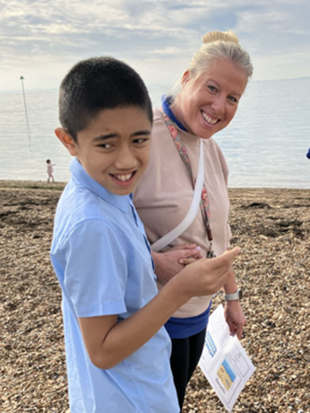
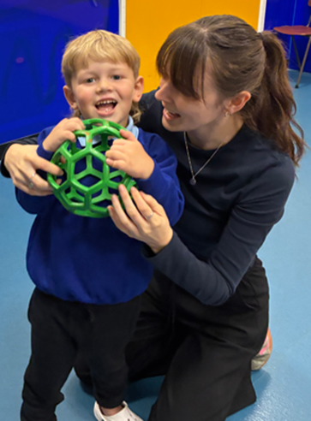

Kingsdown School Autumn Term Newsletter - October 2026
National Teaching Assistant Day 2026
On Friday 25th September, we proudly celebrated National Teaching Assistant Day, a special opportunity to recognise and thank the incredible team of Specialist Support Assistants (SSAs) who make such a profound difference to the lives of our pupils every single day.
At Kingsdown School, our SSAs are at the heart of everything we do. Their role extends far beyond providing classroom support. They bring a wealth of knowledge, specialist skills, compassion and dedication that help ensure every child receives the care, encouragement and opportunities they need to thrive.
Our SSAs play a vital role in supporting pupils' wellbeing, communication, independence and learning. They develop strong relationships with children and their families, understand each pupil's unique needs, and work tirelessly to ensure that every child feels safe, valued and able to succeed. Their expertise enables our pupils to access the curriculum in meaningful and engaging ways, helping them make outstanding progress and achieve their full potential.
As teachers, we are incredibly fortunate to work alongside such talented professionals. Their insight, creativity and commitment enrich our classrooms and strengthen our school community. They are often the reassuring presence, the encouraging voice and the helping hand that enables a child to overcome challenges and celebrate success.
To mark the occasion, we held a special celebration at the end of our weekly assembly. Pupils and staff came together to show their appreciation for our SSAs, with a celebratory song and a joyful dance back to the classrooms. The smiles, laughter and enthusiasm from everyone involved reflected just how much our SSAs mean to our school community.
Quite simply, we could not do what we do without them.

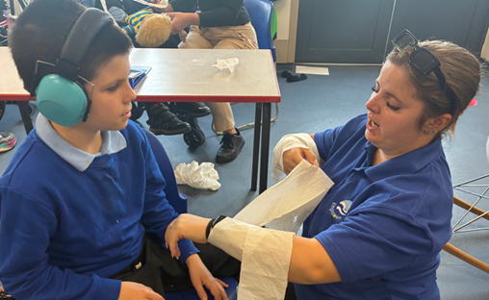

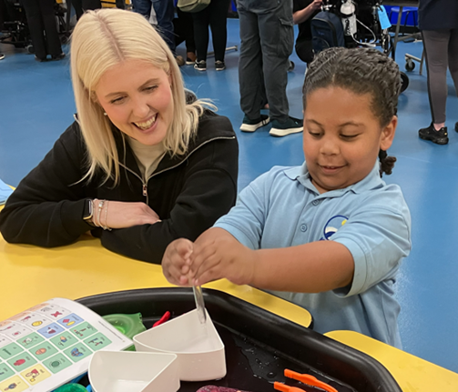

Kingsdown School Autumn Term Newsletter - October 2026
Join Friends of Kingsdown
We are always looking for ways to make Kingsdown School an even more exciting, enriching and enjoyable place for our pupils and families. One of the best ways to get involved is by becoming part of our Parent Teacher Association, Friends of Kingsdown.
Friends of Kingsdown plays a vital role in supporting the school community by organising events, raising funds and bringing families together. We would love to welcome new members this year, and membership is open not only to parents and carers, but also to grandparents, relatives and friends of the school.
You may feel that you do not have a particular skill to offer, but please do not let that put you off. We are simply looking for people who are willing to share their ideas, enthusiasm and a little of their time. Every contribution, no matter how small, can make a real difference to our pupils and families.
Last year, Friends of Kingsdown achieved some fantastic successes. Through their fundraising efforts, they helped raise money towards our new minibus, which is already enhancing opportunities for our pupils. They also played an active role in organising and supporting our much loved Family Easter Disco and Easter Bonnet Parade, helping to create memorable experiences for everyone involved.
We are excited to see what can be achieved this year and would love for you to be part of the journey. Whether you can attend meetings regularly, help at occasional events, share ideas, or simply offer support when you can, your involvement will be greatly valued.
If you would like to find out more about Friends of Kingsdown or are interested in getting involved, please contact Donna Slattery (dslattery@kingsdown.sentrustsouthend.co.uk) We look forward to welcoming you to the team!

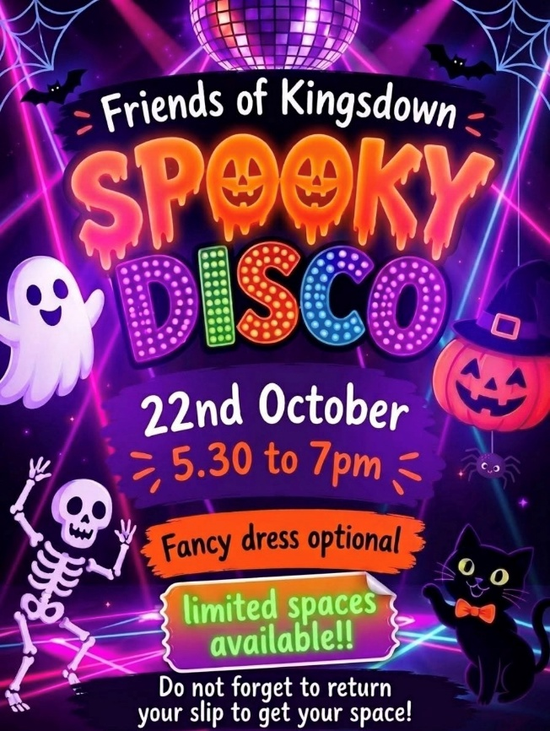

Kingsdown School Autumn Term Newsletter - October 2026
Celebrating our Silver MATP Award
Kingsdown School has been awarded the Silver Award for our Motor Activity Training Program (MATP), a wonderful achievement that recognises the high quality opportunities we provide for pupils to develop their physical skills, confidence and participation.
This award is a testament to the dedication, expertise and commitment of our staff team, who work tirelessly to ensure that every pupil can access meaningful and engaging physical activity tailored to their individual needs. Through MATP, our pupils have the opportunity to experience success, build confidence and celebrate their achievements in a supportive and inclusive environment.
I would like to offer particular thanks to Emma, whose passion, leadership and commitment have driven this initiative forward. Emma has worked tirelessly to develop our MATP provision, ensuring that pupils receive high quality experiences that promote both physical development and enjoyment. Her enthusiasm has inspired both pupils and colleagues alike, and this recognition is richly deserved.
However, this achievement truly belongs to the whole staff team. The success of MATP would not be possible without the active support of our teachers, teaching assistants and therapists, who encourage, motivate and celebrate our pupils during every session. Their collective efforts have helped create a programme that places pupils' achievements and wellbeing at its heart.
A particular highlight of the year was our MATP Event held during the summer term. This was a fantastic opportunity not only to showcase the achievements of our pupils, but also to share our outstanding practice with colleagues from schools across Essex, including Lancaster School. By opening our doors and sharing our expertise, we have helped support other schools to develop their own provision, enabling even more pupils to benefit from the opportunities that MATP provides.
The willingness of our staff to share their knowledge and champion inclusive practice beyond Kingsdown School is truly commendable. It reflects our commitment not only to our own pupils, but also to improving opportunities for children and young people across the wider SEND community.
We are incredibly proud of this achievement and grateful to everyone who has contributed to it. Most importantly, we are proud of our pupils, whose enthusiasm, determination and joy continue to inspire us every day.

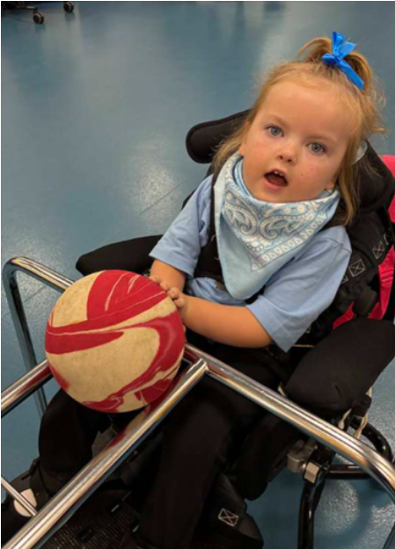
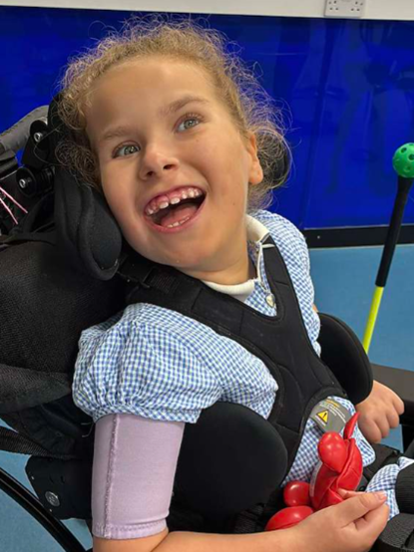
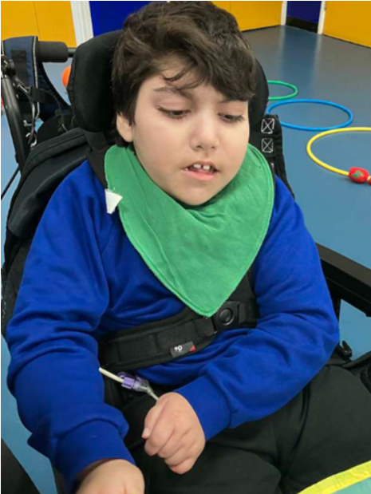

Kingsdown School Autumn Term Newsletter - October 2026
Fundraising, Friendship and Plenty of Cake!
This term has been a busy one at Kingsdown School, with our school community coming together to support two wonderful fundraising events: Jeans for Genes Day and the Macmillan Coffee Morning. Both events provided fantastic opportunities to raise money for worthwhile causes while strengthening the sense of community that makes Kingsdown such a special place.
Our Jeans for Genes Day was a great success, enabling pupils, staff and families to come together to raise awareness of genetic conditions while supporting an important national charity. I am delighted to share that we raised £103.50 through our fundraising efforts. The day culminated in a fantastic "Dance in Your Denim" wheelchair dance, which brought smiles, laughter and celebration across the school. Pupils and staff thoroughly embraced the occasion, demonstrating once again how much joy can be found in coming together for a good cause.
We also hosted our annual Macmillan Coffee Morning, which raised additional funds for Macmillan Cancer Support. Alongside the fundraising, the event provided a wonderful opportunity for parents, carers and staff to enjoy some delicious cake while sharing stories, experiences and support with one another. The sense of warmth, friendship and togetherness in the room was truly heartening to see.
It may seem that we have gone rather coffee morning mad this term, but the opportunity to bring people together is something we greatly value. In addition to our fundraising events, it has been a pleasure to welcome many of the parents of our new pupils into school over coffee and cake. These informal gatherings have provided a lovely opportunity to get to know one another, answer questions and ensure that families feel part of the Kingsdown community from the very beginning.
Building strong partnerships with our families is at the heart of all that we do, and these occasions remind us how important it is to create opportunities for parents and carers to connect, share experiences and support one another. The generous fundraising achieved is a wonderful bonus, but the relationships strengthened through these events are equally important.
On behalf of everyone at Kingsdown School, thank you to all who donated, baked, attended and supported our fundraising activities this term. Your kindness and generosity continue to make a difference both within our school community and beyond.

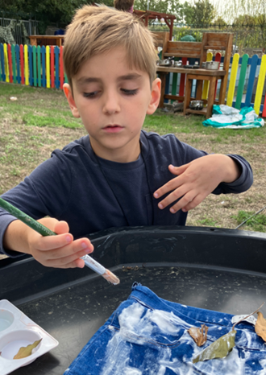
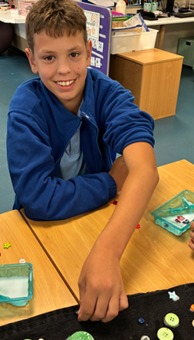
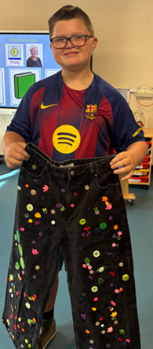

Kingsdown School Autumn Term Newsletter - October 2026
A Wonderful Visit from Gemma’s Farm
It was wonderful to welcome our furry friends from Gemma's Farm back to Kingsdown once again. These visits are always a highlight of the school year, providing our pupils with valuable hands on experiences and creating lasting memories.

Throughout the day, pupils had the opportunity to meet, feed and interact with a variety of animals, including goats, sheep and donkeys. There was great excitement as pupils carefully handled guinea pigs and chickens, developing their confidence and curiosity whilst learning about the animals and their needs.
One of the most heartwarming aspects of the visit was seeing pupils challenge themselves and overcome their initial hesitations. Some pupils gradually built their confidence by grooming the ponies, whilst others took it upon themselves to dive straight in……………………………………... quite literally! Their enthusiasm, courage and sense of adventure brought plenty of smiles and laughter to everyone involved.
At Kingsdown, we know that experiences like these offer so much more than simply meeting animals. They help to develop communication skills, sensory awareness, confidence, responsibility and emotional wellbeing, all whilst creating opportunities for joy and connection.
A huge thank you to Gemma's Farm for another fantastic visit. We are already looking forward to welcoming them back to Kingsdown in the future.

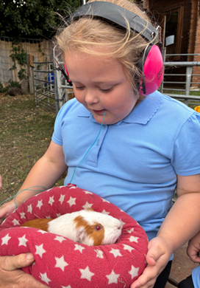
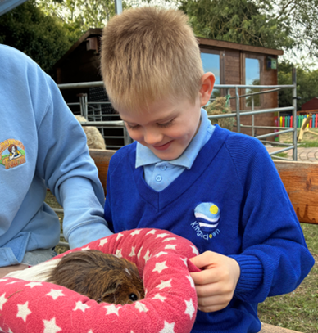

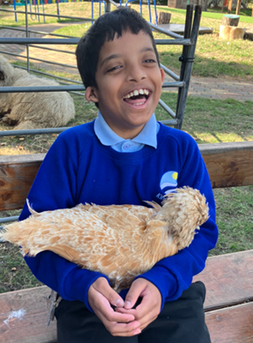
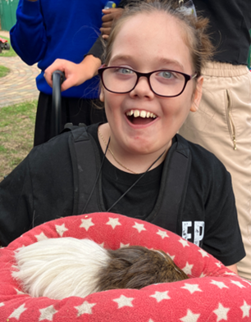

Upcoming dates for your diary:
Great Athlete's visit - Steve Frew - 21st October

After School Spooky Disco - 22nd October

Non Pupil Days 23rd October & 2nd November

Half term - 27 October - 31 October

Kingsdown School Autumn Term Newsletter - October 2026



