Background Information
The Early Years Foundation Stage (EYFS) statutory framework is a set of standards that all early year’s providers must meet to give children the best chance to progress and develop in a safe and healthy environment. When the DfE reviewed it in 2021, it provided an opportunity for us to review our curriculum, its delivery, and assessment.
The assessment framework Development Matters was considered too broad for our pupils, and it was not able to fully recognise the pupils' progress or be used as a formative assessment tool to adapt teaching and learning. Therefore, starting in September 2021, Kingsdown School adopted the Cherry Garden Assessment. While taking into account the holistic development of the child, it continues to focus on the seven main areas: communication and language, physical development, understanding the world, literacy, mathematics, expressive arts and design, and personal, social, and emotional development.
At Kingsdown School, pupils in Lions, Penguins and Ducklings Class predominantly follow the statutory framework for the Early Years Foundation Stage as its curriculum, which is personalised for individual pupils. This is The Blossom Pathway.
Progress during these years will determine the most appropriate curriculum onwards: the Orchid Pathway predominantly for pupils with SLD, and the Tulip Pathway for pupils with PMLD.
All pupils are baselined within 6 weeks of joining the school, or from the start of the academic year. Focus weeks take place throughout the year for each child, enabling professionals and parents to contribute to their child’s progress, and are used to inform further learning. Evidence of pupil progress is recorded using Tapestry, and ‘tagged’ against the Cherry Garden assessment framework.
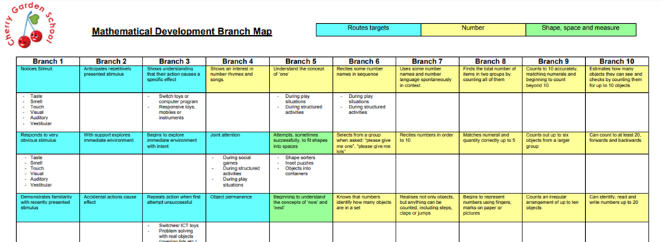
Pupil progress is monitored formally each term. In the spring term, progress data is reviewed to identify pupils who may not be making acceptable progress to enable more enhanced support to be given. The summer term assessments are used as a comparison to the baseline that took place at the beginning of the year. The change in progress is calculated to recognise individual pupils’ progress, and progress in each curriculum area, to inform whole school development.
The Cherry Garden Assessment Framework
This assessment framework enables the seven main EYFS curriculum areas to be assessed, with each comprising different themes, and each theme consisting of 1-10 branches of development.
The progress of individual pupils is discussed with class teachers termly to monitor the pupils’ progress. To inform areas of strength and possible areas to develop, the prime areas (shown below) are analysed more formally, considering whether the cohort is indicating less than expected progress, expected progress, or above expected progress.
- Language and Communication (including Attention and Understanding)
- Physical development
- PSED
- (Mathematical Development)
When considering the pupils' progress from their baseline at the beginning of the year, recognised that some pupils may display a spikey profile. However, it is considered that pupils who are emerging would be achieving below the lowest threshold, and pupils who are exceeding expectations. The threshold for expected progress is:
 | Progress
PMLD | 50% – 2 levels
SLD | 1 – 3 levels

Pupil Progress
At the beginning of 2025/26 the ‘expected progress percentages’ were reviewed. This was necessary as, since adopting the Cherry Garden Framework, and teachers becoming more familiar with the branches, it was apparent that the majority of pupils were achieving above expected progress. Although this should be celebrated, it was considered that the original benchmarks were too low. As a result of this, significant adaptations were made to the expected progress criteria which now reflect our high expectations.
For this reason pupil progress for 2025/26 cannot be compared to previous years.
Communication, Language and Literacy
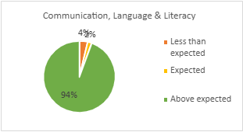

The pie chart above presents a clear overview of pupil performance in the Communication, Language, and Literacy area of early education. The data is segmented into three categories: Above Expected, Expected, and Less Than Expected. 94% of pupils, are performing above expected levels, indicating strong outcomes in communication, language, and literacy development. Kingsdown School has been awarded Centre of Excellence in recognition of its work with The Balanced System. Following an audit of communication across the school, core communication boards were introduced, and over time have been embedded within each classroom, and areas of the school. RISE has also become a prominent feature in the EYFS classrooms which is focusing on learning once the pupils have been given time to regulate first. In addition to this accurate identification of pupils in need of further support has enabled focused intervention work to take place by ChattyBoxx. This model of quality first teaching alongside high quality focused interventions have contributed to our pupils excelling in this area from their starting points.
Physical Development
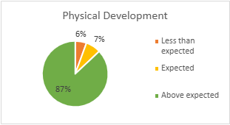

This chart provides a clear visual representation of the physical development levels amongst the EYFS cohort. The largest proportion, 879% of pupils, falls within the above expected range, indicating excellent progress from their starting points.
A significant factor contributing to this success if the continued effort to keep our swimming pool open and accessible to pupils, and our Motor Activity Training Programme (MATP) which has had a significant impact on those pupils who reply on wheelchairs and walking frames. MATP has been broadened to a wider group of pupils this year, enabling more pupils to benefit from this area of the curriculum.
Closer analysis of individual pupils indicates pupils performing slightly better in fine motor skills than gross. However, those pupils whose gross motor skills have not progressed as expected have all had considerable time off school. Without access to specialist equipment in the home, gross motor skills can deteriorate, or not be maintained very quickly.
Personal, Social and Emotional Development
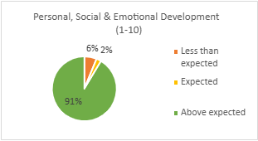

The pie chart above indicates personal, social and emotional development as a strength of the curriculum with 91% of pupils making above expected progress from their starting points. Within EYFS there is a strong emphasis in particular in the areas of independence and building relationships. Many of our pupils arrive with the skills to be independent but due to their parents tending to complete things on their behalf they have not had a focused opportunity to develop self-care and independence skills until starting school. In addition to this, there is a drive to support pupils to work with each other. An emphasis in these areas has promoted pupil progress in this curriculum area.
Emotional Literacy (ELSA) sessions have also had a positive impact on the personal development of pupils, supporting with understanding emotions and building relationships with others, which can then be transferred into the classroom.
Mathematical Development
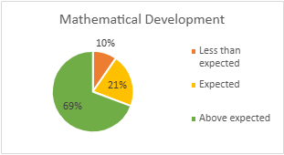

The pie chart above indicates 69% of pupils are making above expected progress in the area of mathematics. Although this is not an EYFS prime area, this leads into the Orchid and Tulip Curriculum as the pupils become older and hence it is an important area to consider. It forms the foundation of future learning.
Although not as successful as communication, language and literacy, and personal, social and emotional health, this does indicate a positive area of the curriculum where pupils are learning well.
Expressive Arts and Design Understanding the World
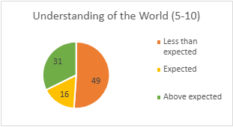
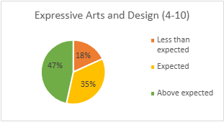

It remains difficult to show progress in both of the curriculum areas given above, purely because each branch begins at 4/5. Due to the complex special educational needs of our pupils the majority of our pupils are yet to indicate learning at this branch level, and hence until this point progress thereafter cannot be measured.
Regardless of this, observations on Tapestry indicate these areas to be important aspects of the curriculum to facilitate learning in other areas.
Conclusion
The analysis of pupil progress across the Early Years Foundation Stage (EYFS) for the academic year 2025/2026 indicates excellent progress in the four areas of the curriculum.
Communication, language and literacy remains the most successful area of the curriculum with 94% of pupils making above expected progress.
Physical development and personal, social and emotional development continue to also be highly successful areas of the curriculum.
Mathematical development continues to be an area to consider further. Although pupils' progress within this area of the curriculum remains good, in comparison to the others, this may be considered as an area to develop.

