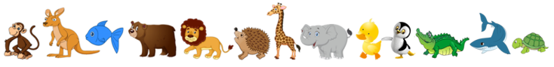
Patterned Pizza

You can have lots of fun creating your own pizza.

Firstly you will need a wrap or pizza base.
Some pizza base sauce and lots of different toppings that you like to eat. Flashcards so you can make your own choices.
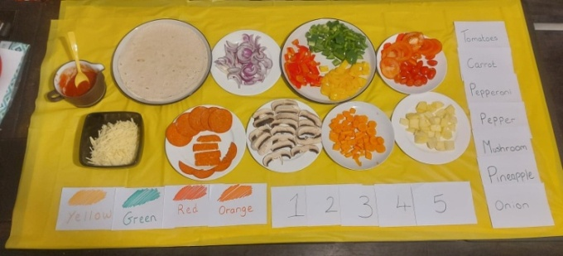

1. Firstly spread the base with your sauce.

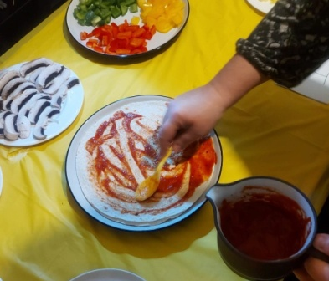

- Then choose from the cards and have fun making your pattern.
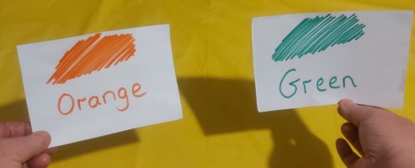

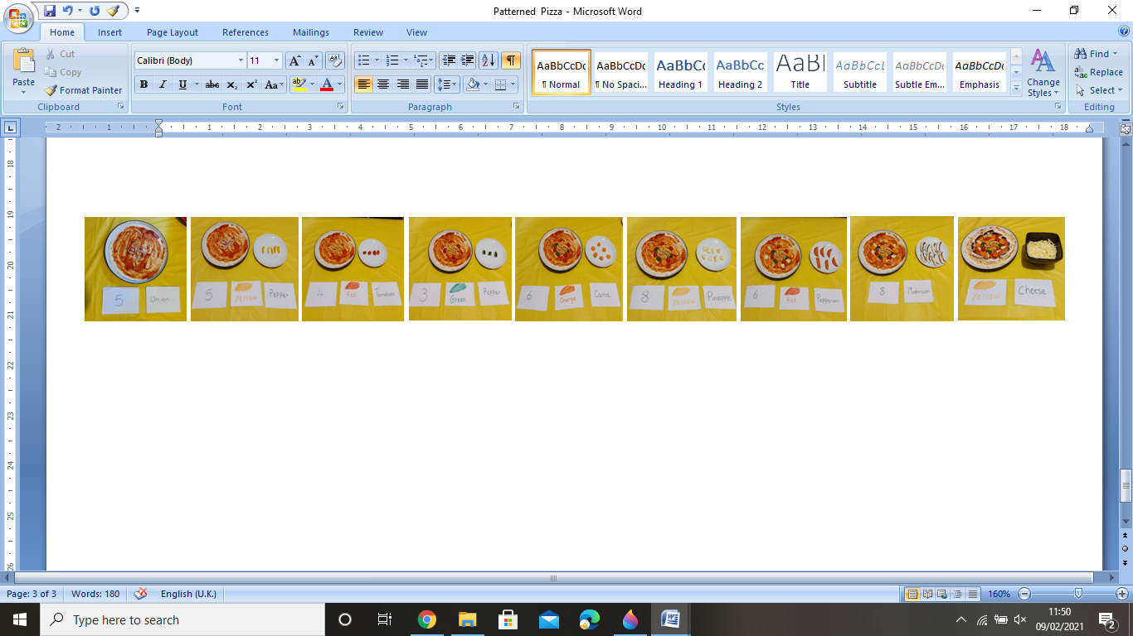
- This is an idea of a pattern.
- Ask an adult to help you put your pizza in the oven for about 15 minutes and then enjoy your
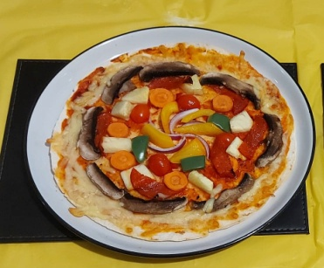
Patterned Pizza.

For your parents:

Flashcards can be easily made. These can be tailored to your child’s level of reading and understanding.
I.E Numbers 1-5 or 1-20. This also applies to colours and ingredients. You could offer a choice of two cards for each category or extend this adding more choices .
I have made some basic ones as shown in the photos as a simple idea. Although if you would like to expand on the activity I have included some templates that the children can make colour or decorate how they would like.

https://www.pinterest.co.uk/pin/563512972099044126/

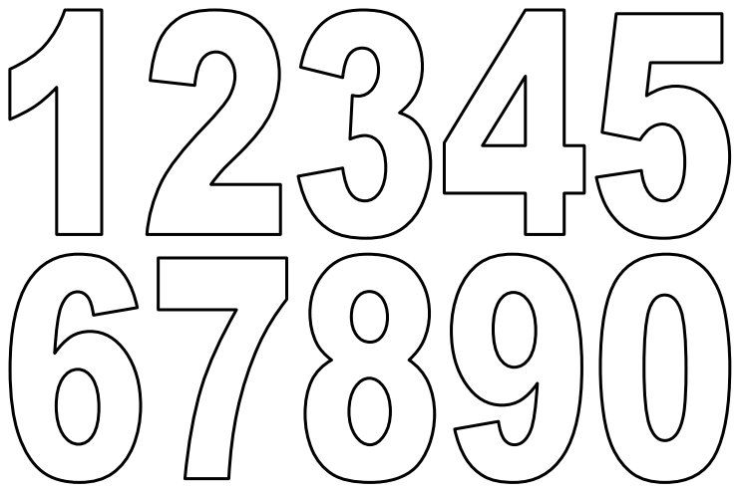

https://coloringhome.com/coloring-page/1676796
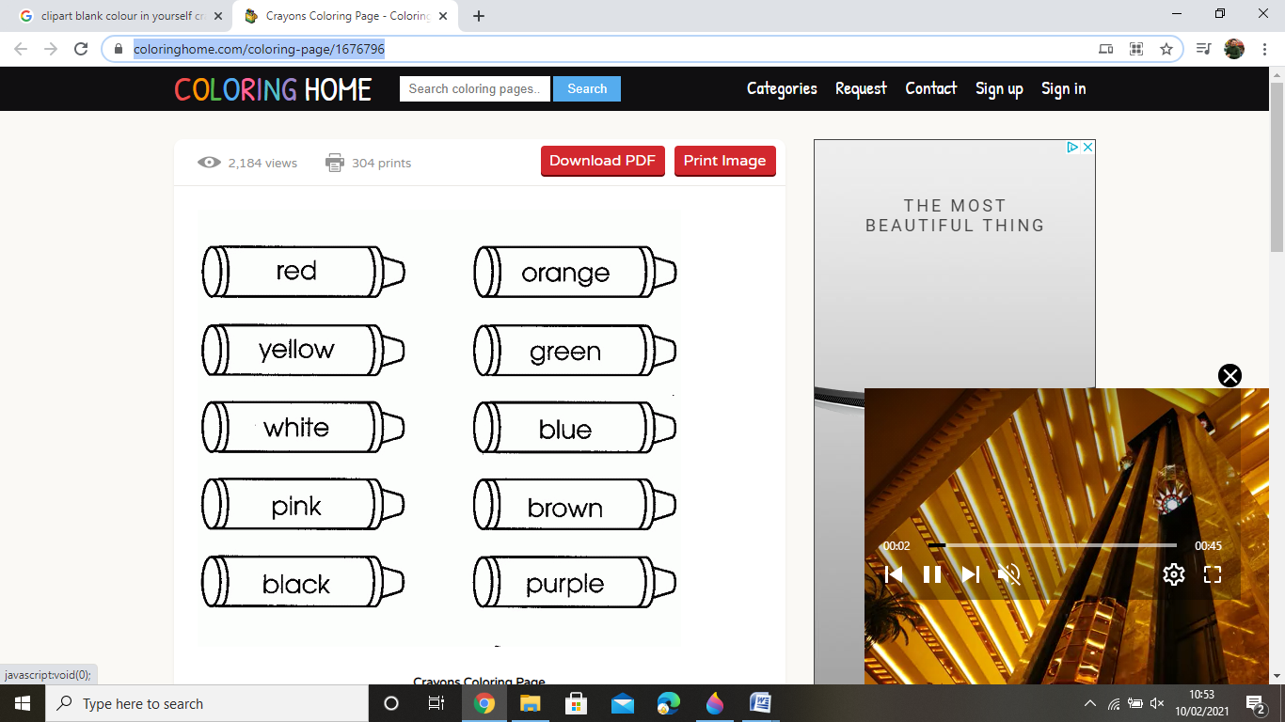

https://www.firstpalette.com/pdf/alphabet-lower-bw.pdf

