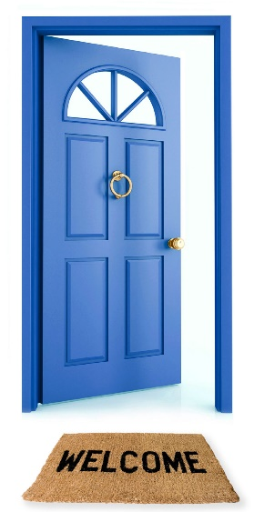
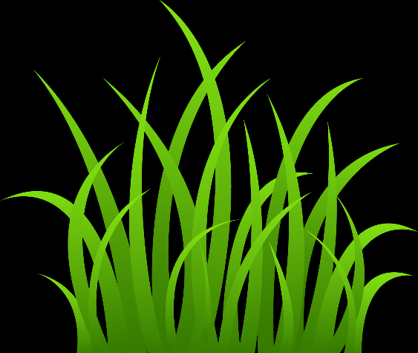
Bear hunt reading comprehension
Instructions:
Cut out the pictures on this sheet. Read the sentences and match the picture to the correct sentence.
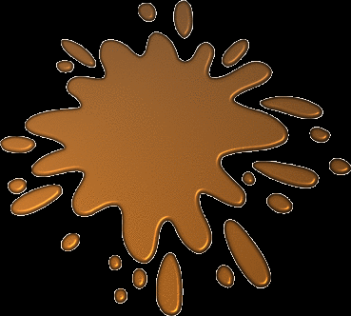
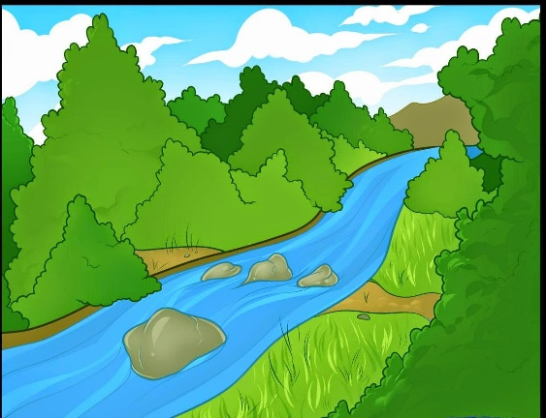
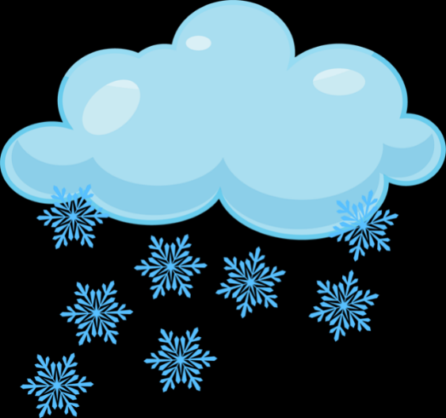
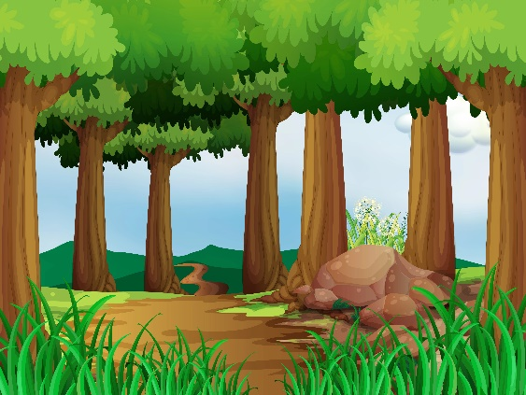
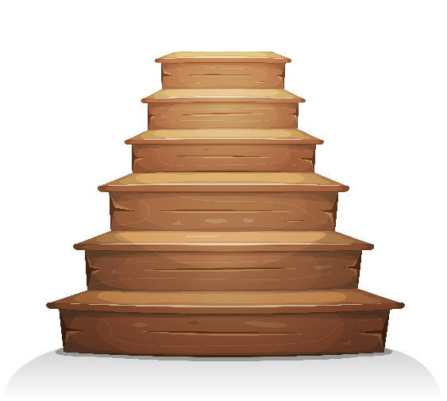
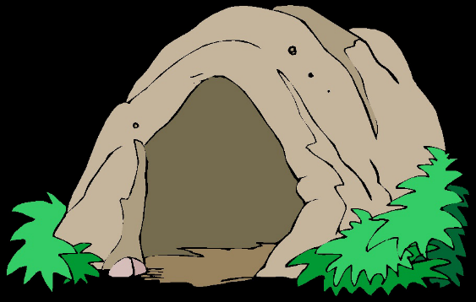
Uh-Oh a snow storm! A swirling, whirling snow storm.
Uh-oh a cave! A narrow, gloomy cave.
Get to our front door. Open the door.
Uh-Oh grass! Long, wavy grass.
Uh oh a river! A deep, cold river.
Uh-Oh Mud! Thick, oozy mud.
Uh-Oh a forest! A big, dark forest.
Quick! Up the stairs.

