Letters, sounds and word games – enjoy reading!

Reading and listening to stories is an enjoyable activity and a wonderful learning experience for all. It’s great to share stories at home and you will learn so much while you are doing something for pleasure and enjoyment. We all like different things and the key is finding what you enjoy/your interests and exploring different ways of learning through your interests. If you have fun and also involve different senses you will gain a deeper learning experience and, therefore, improved understanding.

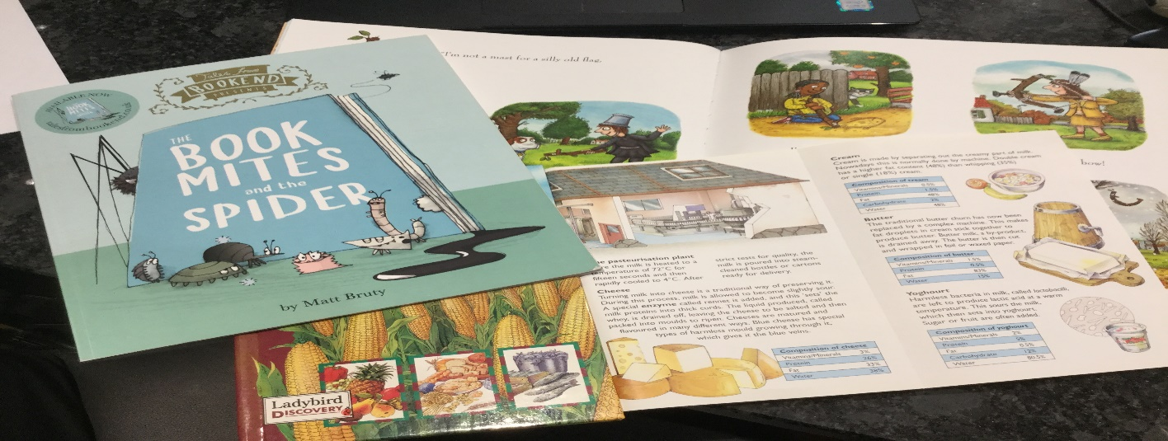

Sharing a book you enjoy is wonderful and letters, letter sounds and words can be enjoyed in so many forms.

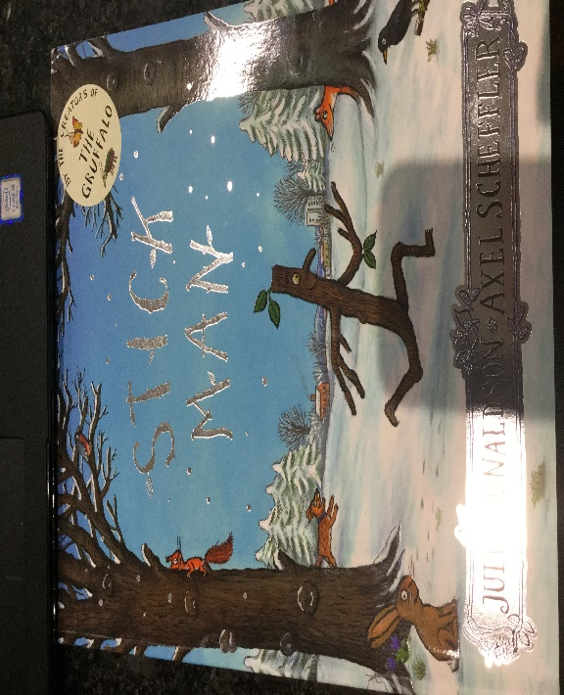

For example when reading Julia Donaldson’s Stick Man story you could focus on:

Key phrases - listen or join in with the key phrases
“I’m Stick Man, I’m Stick Man, I’m Stick Man, that’s me!

Rhyming – “I’ll fetch it and drop it, and fetch it – and then
I’ll drop it and fetch it and drop it again”

Fill in the missing word - “A stick!” barks the …

You will soon begin to recognise some of the words you see in text, when enjoy saying them and using them repeatedly in different ways.

Collect different items from the story – a stick, dog lead… and talk about and feel the items. Talk about some of the pictures and look at the words, acting out “or a hook for a bag” “I’m not a pen”

Look at the pictures – say what you think is happening in the picture. Can you find a word in the text to match your story?

Create a sensory story – using a stick from the garden, water in a tray for the river etc…
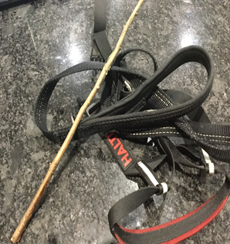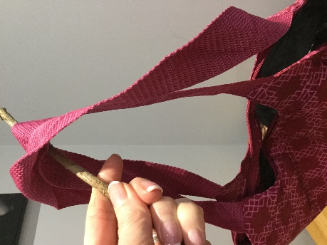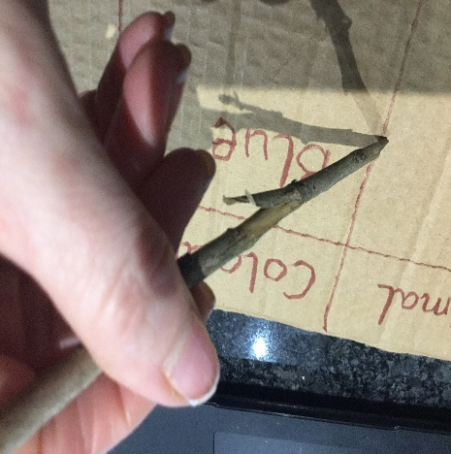

It’s also really lovely to re-create/act out parts of your favourite book. For example - in the Stick Man story, when the children go to the bridge and count 1,2,3 before throwing Stick Man in the river below.

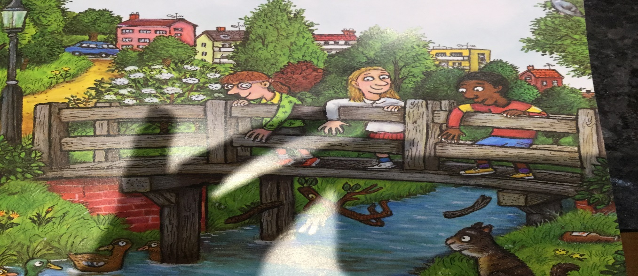

Obviously there are lots of things you can read; poetry, comics, signs outside when walking, fiction and non-fiction, maybe even a joke book.

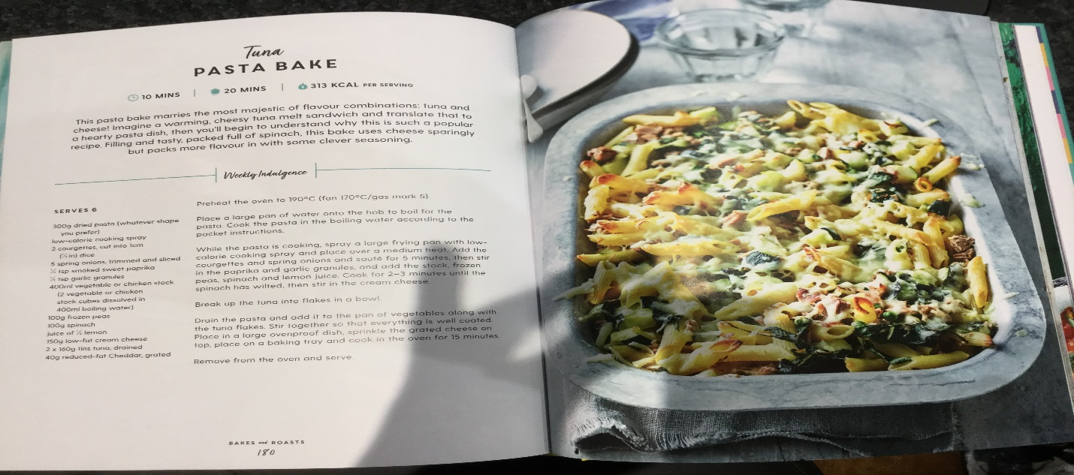

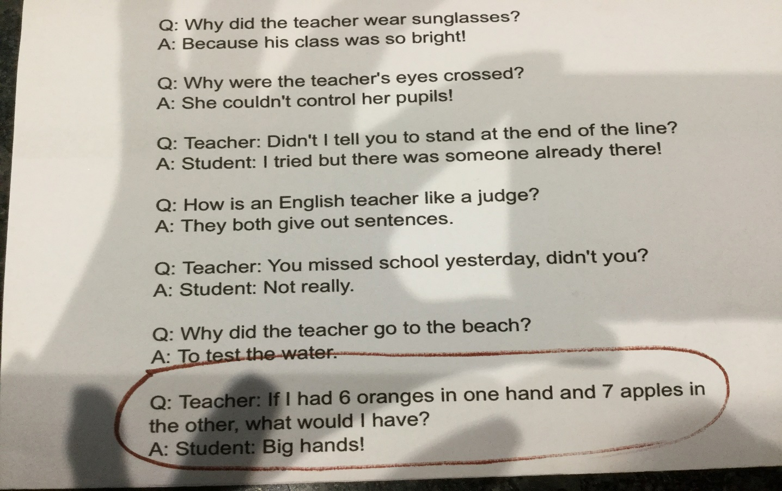

Make a book personal – “Stick Dee” or “Stick Dan”.

Create a word box linked to your story – “Words I can read”.

Ideas and games with letters, letter sounds and words.

Match text to the story.
Find a word in the text of the story.
Make flash cards with words and letters linked to the book.
Hide flash cards around your home to create a word hunt.
Find a particular word in a book.
Count how many times you see a word such as -‘the’.
Label favourite items.
Find items beginning with a particular letter sound.

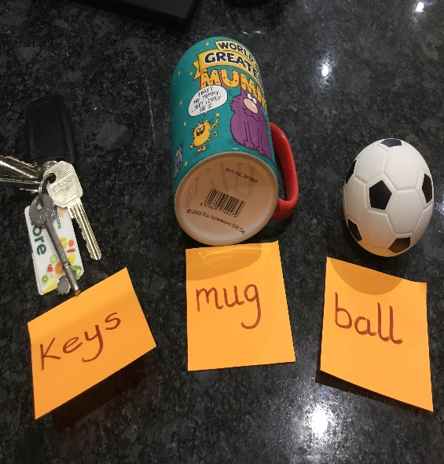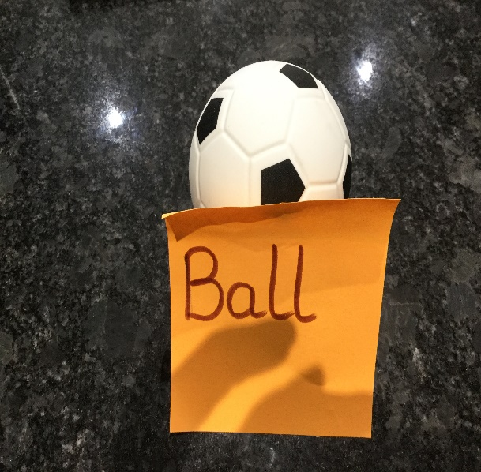

Be active – grab or run to words. Action word – ‘hop’ on ‘hop’.

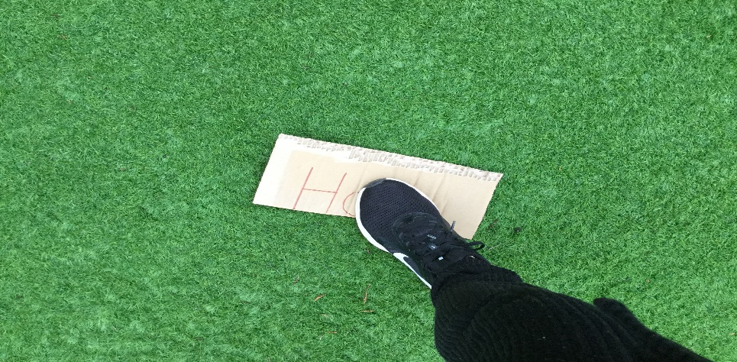

Find a word/letter or sound – Pairs Game or Snap.

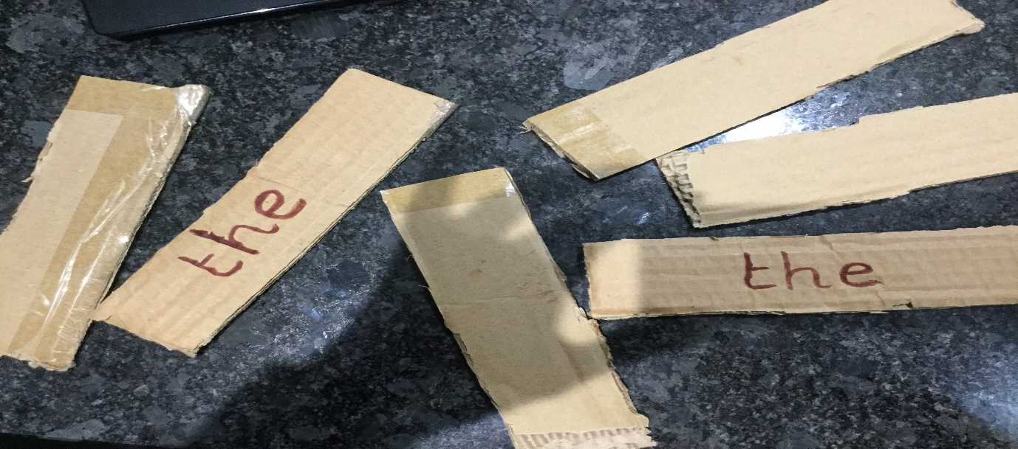

What about the alphabet game? Different categories beginning with a letter sound – Example - b
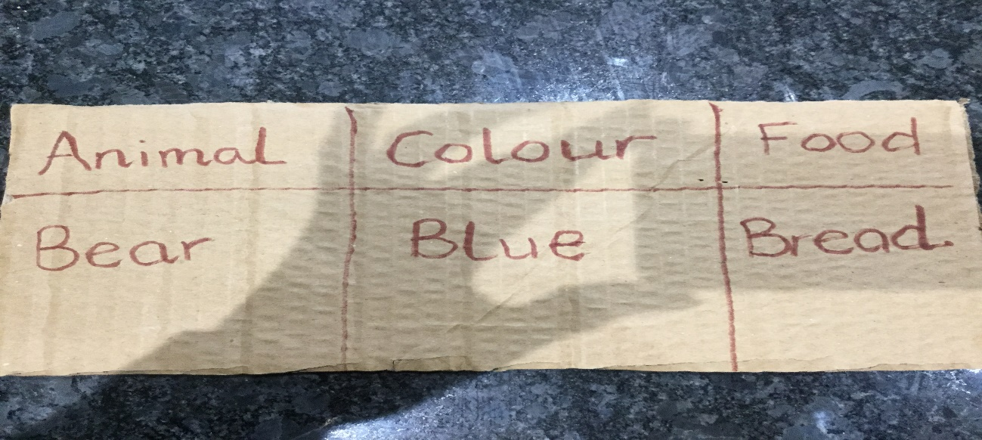
Write or read words in sand.
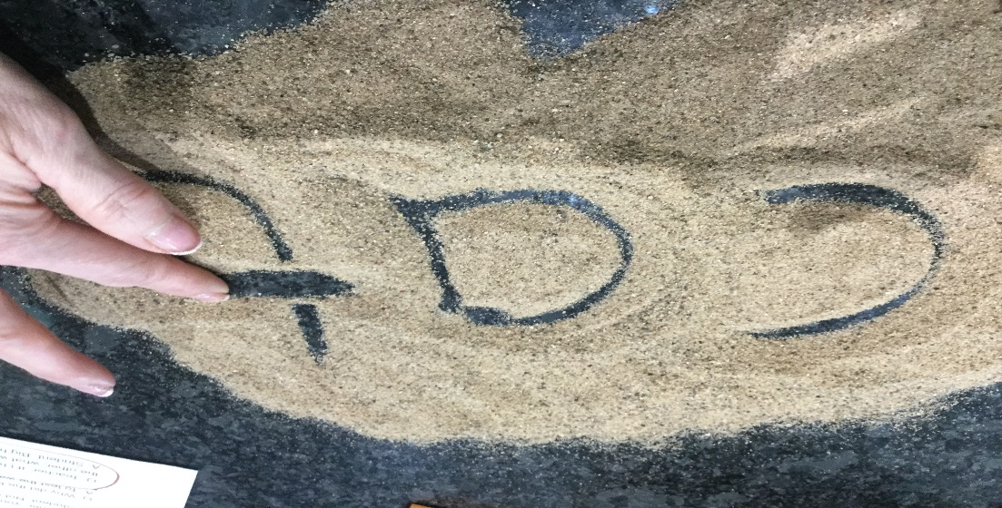
Use the key words from a book to create a word wheel?

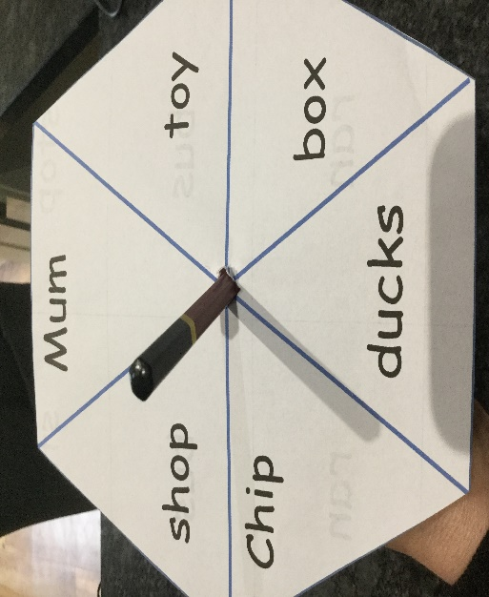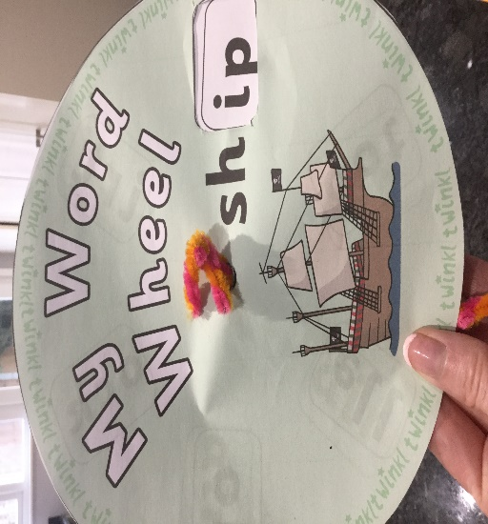

Making things fun for you means you will do it again and learn more and more letters and sounds and words. You will have a better memory, get to know more about new things and improve your imagination. So, find your way of having fun with reading words and have a go!

