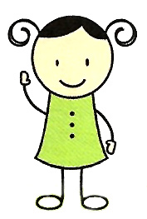
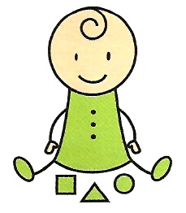
Sensitivity Occupational Therapy services

Please see attached sheet of descriptions of activities. Choose the activities which best fir your child.

Movement/Gross Motor Skills | Tactile/Touch skills | Oral motor skills | Auditory skills.
Balloon pass:  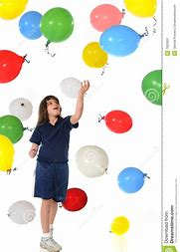 | Sensory bags:  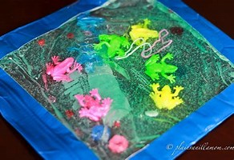 | Pop bubbles:  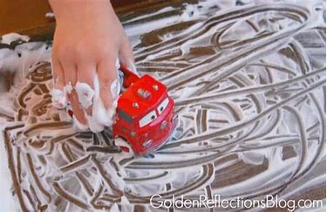 | Activity belt:  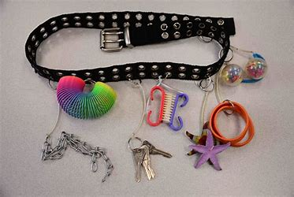
Jump or crawl cushions:  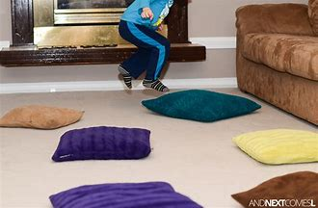 | Dry texture play and sensory bins:  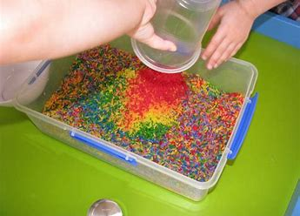 | Drinking “pudding” or applesauce through a straw:  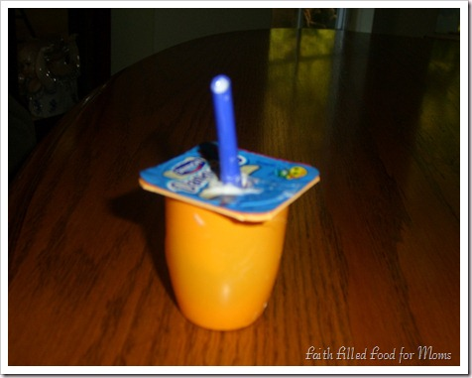 | Muscial shakers:  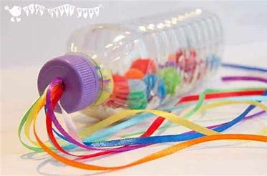
Make a den:  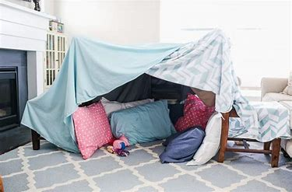 | Messy play:  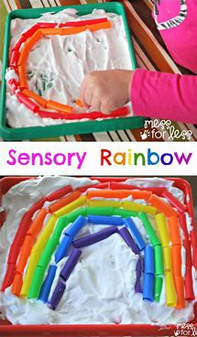 | Blowing party whistles:  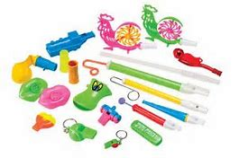 | Sensitvity to nise: Taxing noises.
Crawl through homemade tunnel:  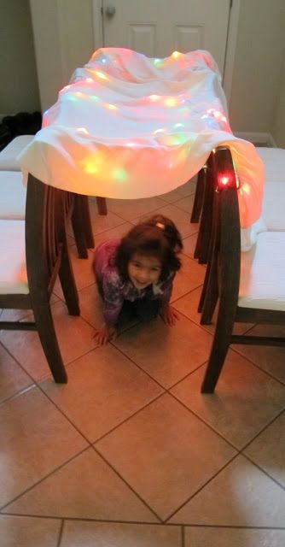 | Messy play food:  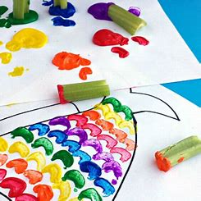 | Blow cotton balls across table:  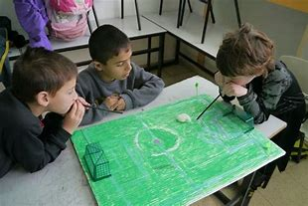 | Peeping musicians:  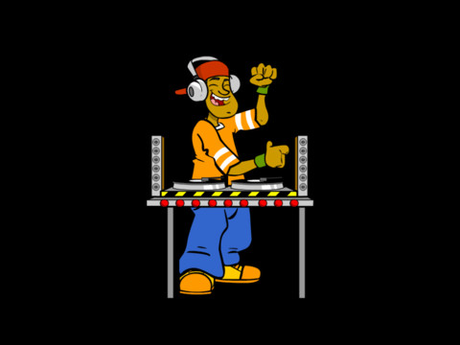

Proprioception/calming | Visual motor skills | Fine motor skills
Towelling and jumping on trampoline/trampet:  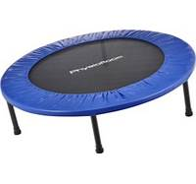 | Toy road:  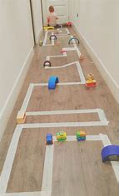 | Taped toys:  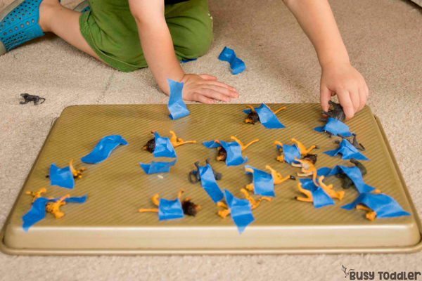
Stress ball squeezing:  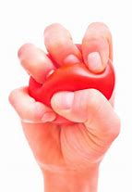 | Calming bottles:  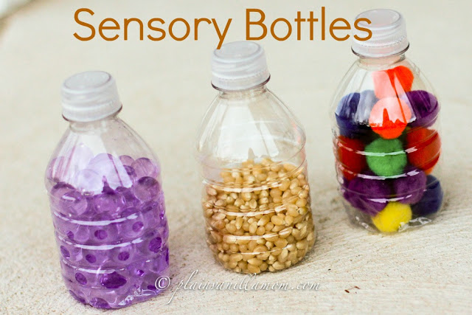 | Drive and drop:  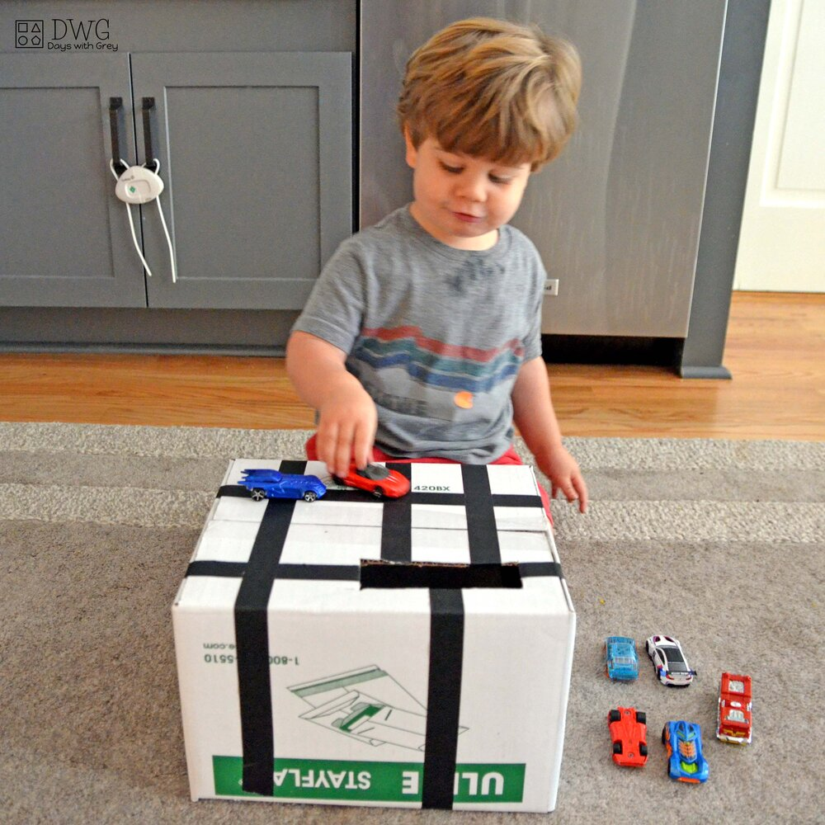
Bouncing on the gym ball:  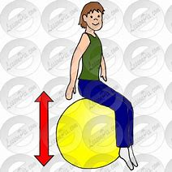 | String lights:  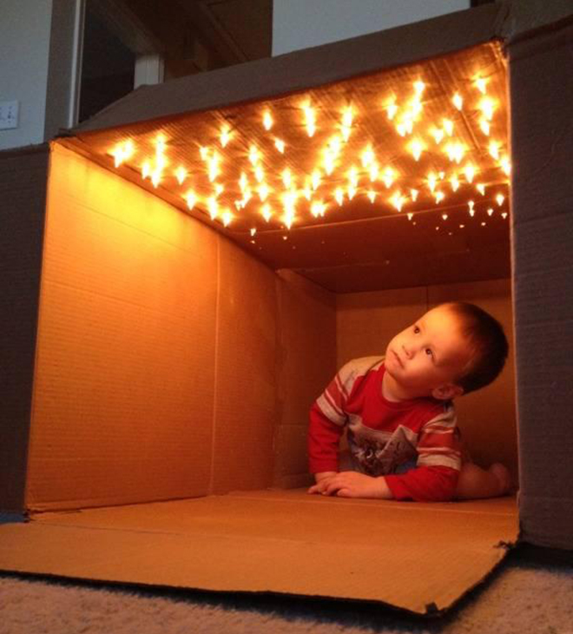 | What’s in the box:  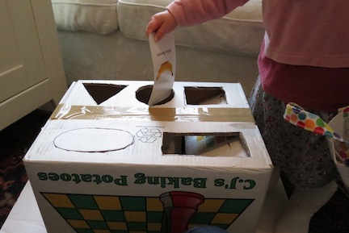
Tummy over the gym ball:  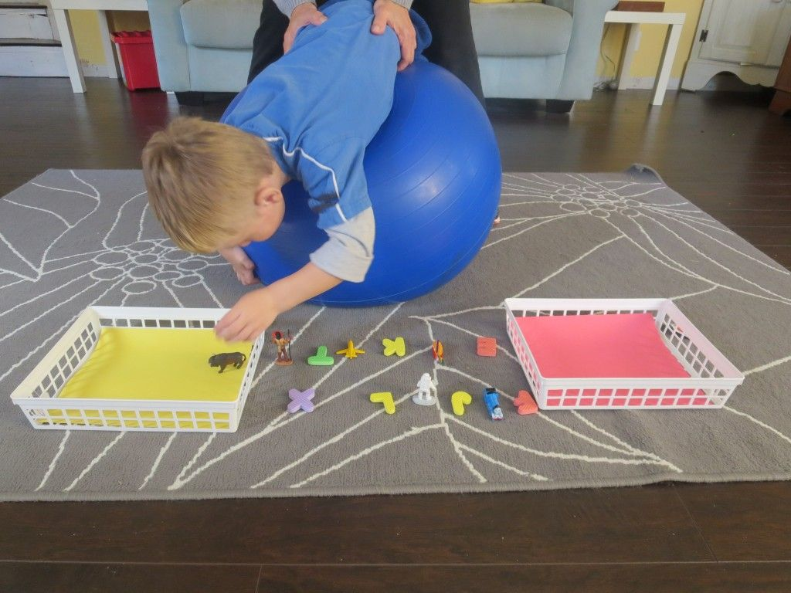 | Apps:  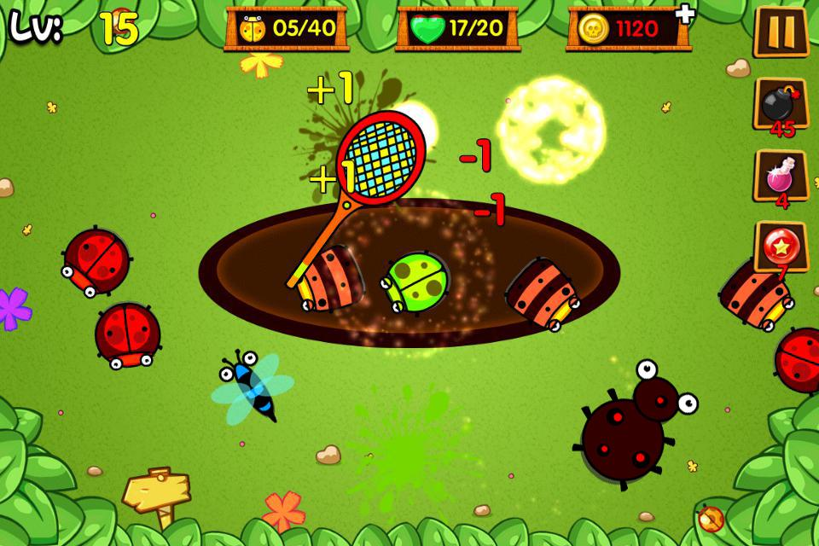 | Put in milk lids:  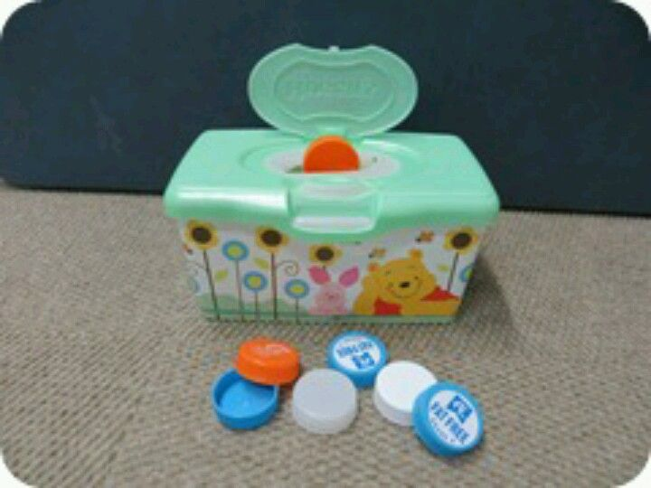
Donna Boygle
Advanced Sensory Integration Practitioner/Occupational Therapist

