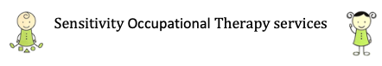
Dear Parents,
The activities in this handout are focusing on strengthening the hands to refine movement, for cutting and pre-writing skills. These activities have been developed for you to do at home with your child, with resources which you most likely might have within your home. You can choose from the activities, which best suit your child.
Fine motor skills:
The pincer grasp is the fine grip between the tips of the thumb and index finger, where the thumb and index finger together form a circular shape. Practice lots of activities that increase the accuracy or strengthen pinch. Any activity that involves pinching with fingers against resistance will increase strength with regular practice.
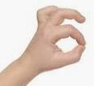
Posting straws:
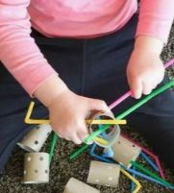
Materials needed: Straws, toilet roll tubes, hole punch
Steps to play: Preparation:
● Punch holes around the toilet roll tubes.
Play:
● The child feeds the straws through the holes in the tubes.
● If you colour in the holes, they can colour match the hole to the straw.
Feed the rubber bands:

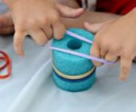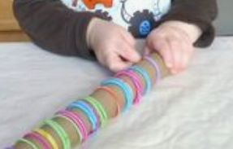
Materials needed: 5 to 10 rubber bands or hair bands, cardboard tube or even a muffin pan turned over (use the back of the cups)
Steps to play:
● Hold the rubber band with two hands and place over the container, one at a time.
Posting earbuds:
Materials needed: Earbuds, scissors, any container with small holes (a box with small holes will also work)
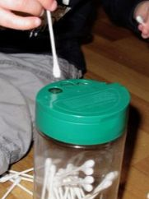
Steps to play: Preparation:
● If you only have a cereal box, poke a few small holes on the large flat side of the box.
● The holes in your container must be large enough for an earbud to fit through.
Play:
● The child should post the earbuds through the holes, one at a time.
Scoop and pour:
Materials needed: dry rice/lentils/beans/pasta, containers and spoons/scoops
Steps to play: Preparation:
● Place the dry rice/lentils/beans/pasta in a larger container with the spoon and scoop.
● Give the child a few smaller containers next to it.
Play:
The child needs to scoop the dry rice with the spoon or scoop into the smaller containers to fill it up.
Posting pipe cleaners:
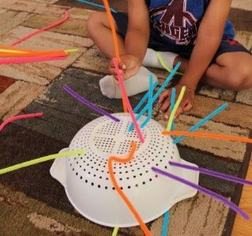
Materials needed: Pipe cleaners, strainer
Steps to play: Play:
The child must take one pipe cleaner at a time and post it into a hole.
Alternatives:
● If the child finds pipe cleaners difficult, practice first with long straws. As the straws are firmer, it is easier to do.
Two handed activities:
Squeezing cotton:
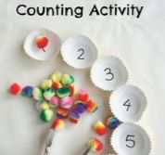
Materials needed: kitchen tongs, cotton wool balls/pompoms, cupcake cases and marker
Steps to play: Preparation:
● Write a number (which your child can recognise) within the cupcake cases e.g. 1, 2, 3, 4, 5.
Play:
● The child must pick up the cotton wool/pompoms with the tongs and place it one by one in the cupcake case, until they are filled up with the correct amount e.g. a number 4, they will need to place 4 balls.

Draw the shape:
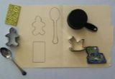
Materials needed: Paper, pencil, various kitchen utensils
Steps to play:
● Place the kitchen utensils and cookie cutters on a page.
● Hold it with one hand steady and draw with your other hand around it, to draw its shape.
● Colour in and decorate the drawings.
Peg Numbers:
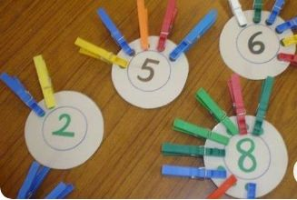
Materials needed: Paper, pen, scissors and clothing pegs
Steps to play: Preparation:
● Cut out four circles.
● Write numbers on the circles e.g 1, 2, 3, 4
Play:
● The child needs to place the same number of pegs as the number on the circle, on the edge of the circle.

Scoop and transfer
. 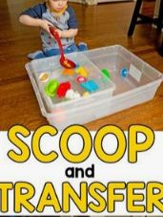 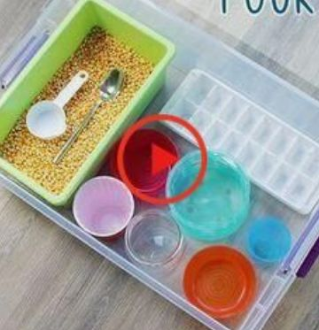
Materials needed: Two large bowls, various plastic toys, large food spoon.
Steps to play: Preparation:
● Place the plastic toys within a bowl of water.
Play:
● The child needs to scoop the toys out of the bowl of water and place it in the bowl next to.
Pasta and straws:
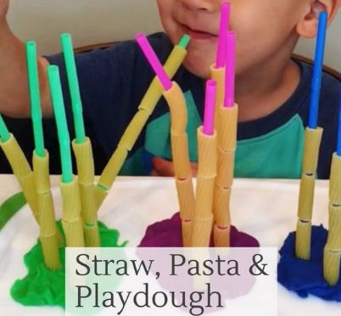

Materials needed: Playdough, penne pasta pieces, straws Steps to play:
● Roll a large ball with the playdough.
● Stick the straws into the playdough, so that they are standing up.
● Feed the pasta into the straws. How many pasta towers can you make?

Strengthening with play dough:
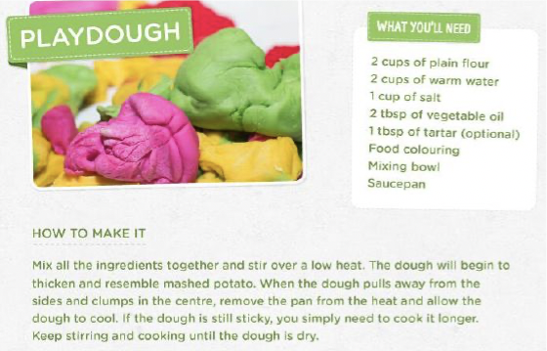
Pinch the snake:
Materials needed: Play dough
Steps to play:
● The child rolls the play dough into a sausage. Make sure they keep their fingers straight. Rolling enables you to use your whole arms, bending and straightening the elbow.
● Once you have rolled out the dough, using your thumb and index finger, pinch
the dough as hard as you can.
● Pinch all along the snake.
● Alternative: Roll snakes to make the shapes.
Press in holes:
Materials needed: Play dough
Steps to play:
● Using both hands, press down onto the play dough,
keeping arms straight. It is a good idea to stand up or kneel at a table, this encourages further pressure.
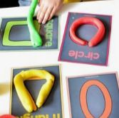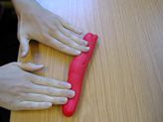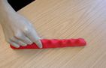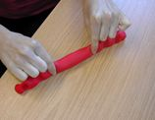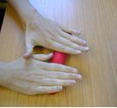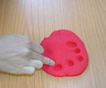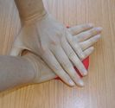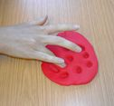
● Once the dough has been rolled out you can use different fingers to make prints in the dough. Keep your fingers straight as if you were pointing.
● Alternative: Use Legos to press into the dough, to make play dough prints. Roll large balls:
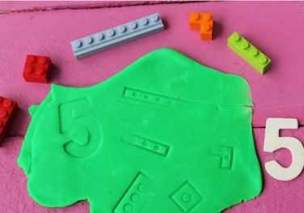
Materials needed: Play dough
Steps to play:
● Roll large balls between the palms of your hands.
● Stick cut up straws or pieces of pasta in it to make a bug.
Roll small bird eggs:
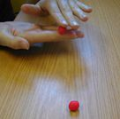
Materials needed: Play dough
Steps to play:
● Use the tips of your fingers to roll small balls.
Make a basket with eggs. Find the toy:
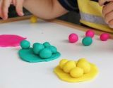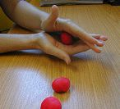
Materials needed: Large piece of play dough, small toys. Some children are safe with the use of beads (which works very well), others need larger objects such as small plastic insects or animals; or even pasta pieces.
Steps to play: Presentation:
● Hide the toys inside of the playdough.
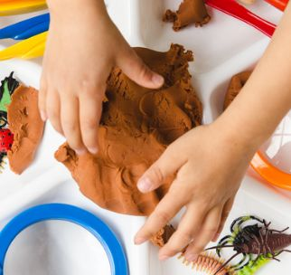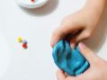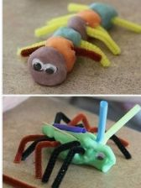
Play:
● The child must find all the toys in the playdough.
Pencil control:
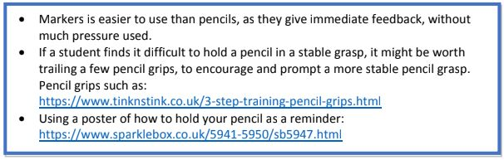
Developing good pencil control is an important prerequisite for drawing and writing.
Drawing on your back:
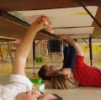
Materials needed: Paper, markers/crayons, tape, coffee table or dining room chair
Steps to play: Preparation:
● Tape a paper to the bottom of a low coffee table or dining room chair. The height needs to be as such, for the child to lay on their back under that chair and draw on the paper. This again encourages hand motions, rather than full arm motion when drawing.
Play:
● The child can d​raw a picture in this position. Draw a scribble monster. Do this by scribbling a large shaped body. Then add the details e.g. hair, face and legs.
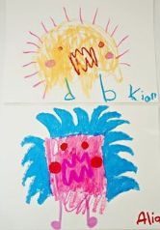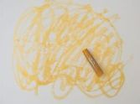
Follow the road:
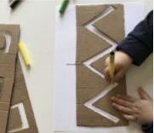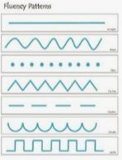
Materials needed: Paper, markers/crayons, cardboard and scissors
Steps to play: Preparation:
● Cut the cardboard into large rectangles to make stencils.
● Draw a large pattern on the cardboard. One pattern per cardboard.
● Cut out the pattern with scissors or box cutters. The cutting should be large enough to leave about a 1cm gap, for the child to draw patterns inside.
Remember to not cut the end of the cardboard, for the pattern to become undone.
Play:
● The child must place the stencil on the pager and draw the pattern, by following the gap of the stensil.
● Remember to start on the left hand side and draw towards the right.
● Remind the child to hold onto the stencil, to keep in still. If this is too difficult, fasten the stencil to the paper with some Blu tack or tape.
Stickers on a pattern.
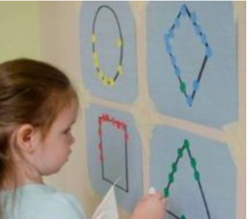
Materials needed: Stickers (round works well), marker and paper
Steps to play: Preparation:
● Draw a shape with the marker on paper.
Play:
● The child needs to start at the one end of the shape and place the stickers next to each other along.
Colour in the circles:
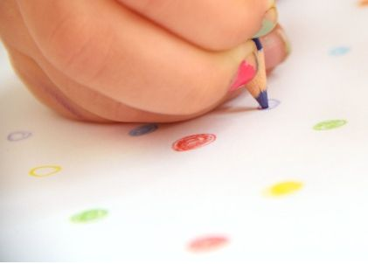
Materials needed: Pencils/markers/crayons, paper
Steps to play: Preparation:
● Draw small circles on a page. The size of the circles will depend on the ability of your child.
Play:
● Provide the child with small crayons or pencils to colour in the circles. Try to stay in the lines.
● Alternative:
● Draw larger circles, if your child finds the small circles harder to colour in.
● Use a few colours. Colour in the circles with the same colours. Draw a path:
Materials needed: Crayons/markers, paper and wooden blocks/lollipop sticks/large stickers
Steps to play: Preparation:
● Place the blocks in a row, at least 5 cm apart.
● Draw the pattern you want to practice, between the blocks, as in the picture.
Play:
● The child draws the pattern between the blocks/stickers.
Some ideas:
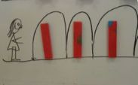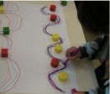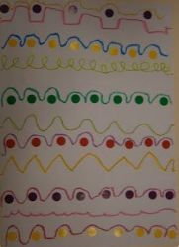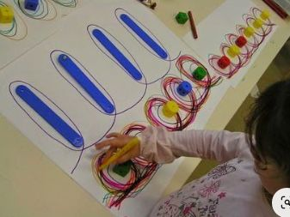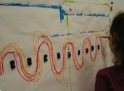
Draw a tornado:
Materials needed: Paper, crayons/markers
Steps to play:
● Practice to draw curly patterns, as if you draw a tornado or the shell of a snail.
● The parent can add in the detail to change the picture into a dance or snail, if your child is unable to.
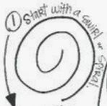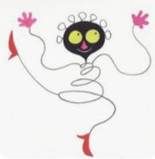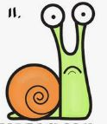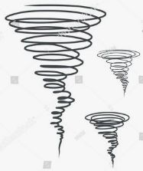
Dot to dot:
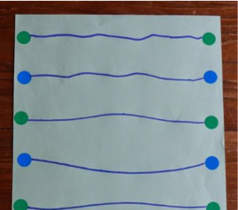
Materials needed: Pencils/markers/crayons, paper
Steps to play: Preparation:
● Draw small circles on a page, on either side (or use stickers).
● Make sure to draw a circle on opposite sides of the page, the same colour.
● Use a different alternative colour e.g. if the first row is green, then second is blue.
Play:
● Child draws with a marker from left to right from one dot to next.
Fruit paths:
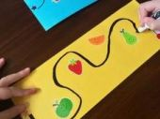
Materials needed: Paper, stickers and markers
Steps to play: Preparation:
● Place the coloured stickers across the page as in the picture. If you do not have stickers, you can also draw a simple picture or shape instead.
Play:
● Demonstrate what you expect to your child with a pencil.
● The child needs to draw the pattern from one end to the other, without touching the
stickers.
Circle the dot:
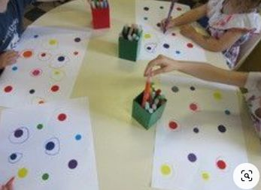
Materials needed: Paper, pencils/markers, stickers
Steps to play: Preparation:
● Place stickers across the page. If you do not have stickers, then draw dots across the page.
Play:
● The child needs to draw a circle with the correct colour around each dot.
Match the peg:
Materials needed: Pegs, paper, crayons/pencil/marker
Steps to play: Preparation:
● Place pegs around the edge of a page.
● If you want to add a matching element to the game, you can draw either with
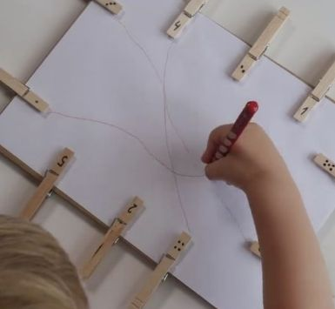
colours, numbers or letters on the pegs.
● Make sure that you place the matching pegs on opposite sides of the page.
Play:
● The child draws from one peg to the matching peg on the other side.
Pre-writing skills:
Materials needed: ​C is for Caterpillar Letter g​ worksheet
The first page of the worksheet is self explanatory.
Monday: Page 2 & 3 - practice letter g for goat .
Tuesday: Page 4 & 5 - practice letter g for gate .
Wednesday: Page 6 & 7 - practice letter g for glass .
Thursday: Page 8 & 9 - practice letter g for gift .
Friday: Page 10 & 11 - practice letter g for guitar.
Scissor skills:
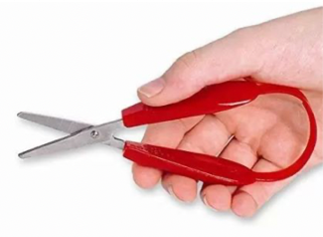
Snippering is one of the first steps in learning to cut with a scissor. When holding a scissor, make sure your child holds it in a thumbs up position. It sometimes helps to draw a small smiley face on their thumb to remind them that the thumb needs to be at the top.
You might want to consider Mini Easy-Grip scissors, if your child finds standard scissors difficult to use. ​https://www.tinknstink.co.uk/mini-easi-grip-scissor.html
We will practice cutting lines, curves and circles (both directions) this week. I’ve attached a ​Twinkl cutting booklet’​ worksheet. If you are unable to print this, there is instructions to how to make:
Use the Twinkl cutting booklet worksheet. If you do not have a printer, then you can draw the lines with a marker and draw a simple picture. The child needs to cut on the line.
Monday: Worksheet page 3 & 4
Tuesday: Worksheet page 5 & 6
Wednesday: Worksheet page 7 & 8
Thursday: Worksheet page 9 & 10: Make sure the child follows the red arrow for the correct direction. Friday: Worksheet page 11 & 12
Please do not hesitate to contact me if you require any further advice or have questions. Kind regards,
Donna Boygle
Independent Occupational Therapist

