
Dear Parents,
The activities in this handout are focusing on strengthening the hands to refine movement, for cutting and pre-writing skills. These activities have been developed for you to do at home with your child, with resources which you most likely might have within your home. You can choose from the activities, which best suit your child. The week schedule has an overview of all the activities.
Follow the road:
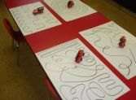
Materials needed: Paper, marker, car or train
Steps to play: Preparation:
● Draw with the marker various lines on the paper. You might want to draw a few different pages.
● Start off with simple lines e.g. straight, wavy and zig-zag; then others that are more complex.
Play:
● The child must place the car at the start of the line and follow the line with the car or train to the end. You might need to demonstrate and guide their hand initially.
● This develops the concept of pencil control and following lines, as what you would do when using a pencil.
Button the pattern:
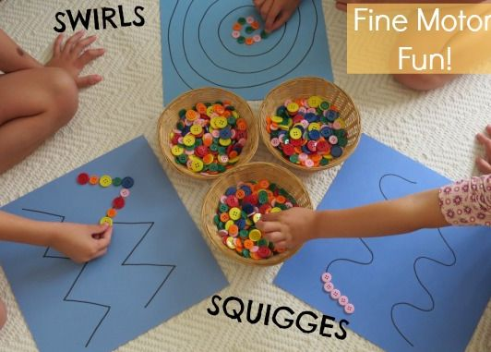
Materials needed: Buttons (or even stickers), marker and paper Steps to play: Preparation:
● Draw a pattern with the marker on paper.
Play:
● The child needs to start at the one end of the pattern and
place the buttons next to each other along the pattern.
● You can also do this with stickers.
Draw on your tummy:
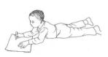
Materials needed: Paper, crayons or markers
Steps to play:
● The child lay on their tummy to draw. This encourages the use of hand movements, rather than using the whole arm in drawing.
● Draw a picture, by using curly and wiggly lines.
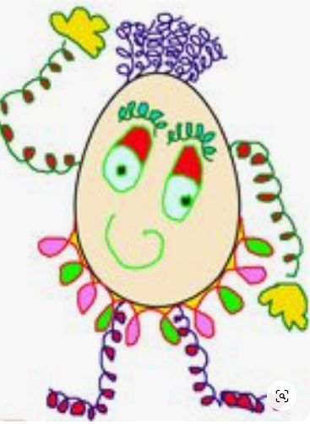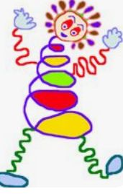

Match the peg:
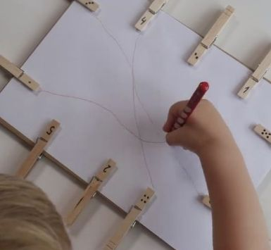
Materials needed: Pegs, paper, crayons/pencil/marker
Steps to play: Preparation:
● Place pegs around the edge of a page.
● If you want to add a matching element to the game, you can draw either with colours, numbers or letters on the pegs.
● Make sure that you place the matching pegs on opposite sides of the page.
Play:
● The child draws from one peg to the matching peg on the other side.
Pre-writing skills:
Materials needed: C is for Caterpillar worksheet Letter S
The first page of the worksheet is self-explanatory.
Monday: Page 2 & 3 - Snake
Tuesday: Page 4 & 5 - Snail
Wednesday: Page 6 & 7 - Sun
Thursday: Page 8 & 9 - Ship
Friday: Page 10 & 11 - Spoon
Scissor skills:
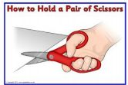
Snippering is one of the first steps in learning to cut with a scissor. When holding a scissor, make sure your child holds it in a thumbs up position. It sometimes helps to draw a small smiley face on their thumb to remind them that the thumb needs to be at the top.
you might want to consider Mini Easy-Grip scissors, if your child finds standard scissors difficult to use. https://www.tinknstink.co.uk/mini-easi-grip-scissor.html
We will practice cutting shapes with corners this week.
All the following activities are on the ​Cutting shapes ​and Cut build a dino shape worksheets​.
Cutting shapes worksheet
Monday: Worksheet page 1 - Cut out the rectangle pictures
Tuesday: Worksheet page 2 - Cut out the rectangle animal pictures
Wednesday: Worksheet page 3 - Cut out the triangles
Thursday: Worksheet page 4 & 5 - Cut out the shapes on page 5 and glue them on page 4
Build a dino worksheet
Friday: Build a dino worksheet: Do as many as you enjoy
Please do not hesitate to contact me if you require any further advice or have questions. Kind regards,
Donna Boygle
Independent Occupational Therapist
13th July 2020

