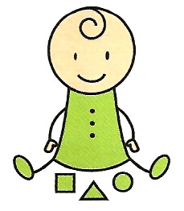
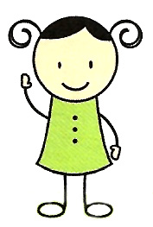
Sensitivity Occupational Therapy services

Dear Parents,

Your child learns by exploring through their senses. These activities have been developed for you to do at home with your child, with resources that you’re most likely to have within your home. You can choose from the activities, which best suit your child. The week schedule has an overview of all the activities. Enjoy!

Movement:
Balloon pass:
Materials needed: Balloons, large yogurt container or large plastic bowl.

Steps to play:
● Throw a balloon up in the air. Show your child to hit it up in the air repeatedly.
● Also try: Pass the balloon over your head or between your legs to another person.
● Also try: Give them a plastic bowl/container to catch the balloon.

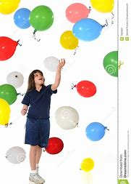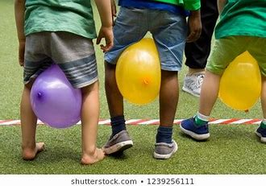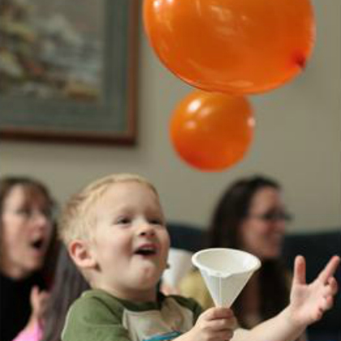

Jump & crawl:
Materials needed: Pillows or cushions

Steps to play:
● Scatter cushions on the floor.
● Let your child jump from one cushion to the other.
● Also try: Let your child crawl between the cushions, not touching them.

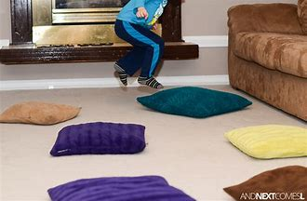

Make a den:
Materials needed: Large sheets, blanket and cushions, chairs (or larger
furniture such as tables), some heavy books.

Steps to play: https://yourkidstable.com/cool-down-spot/
● Decide on a large enough space to build your den.
● Build the base of the den with furniture. If you use chairs, place 2 chairs facing their back towards the den on both sides. Make sure you leave enough room to get inside and move around.
● Drape a sheet over each set of chairs. This will make the walls.
● Next add a large sheet over the top of the den. Secure the sheets by
placing books over the sheets on the seat of the chair. You can secure the top sheet with rubber bands if you need to.
● Add a soft blanket with cushions on the floor space, to make it comfy. You can use this as a calming space for your child, by placing a few motivating toys or books inside for them.

Alternatively you can get build your own den kits or make a den out of a large box.

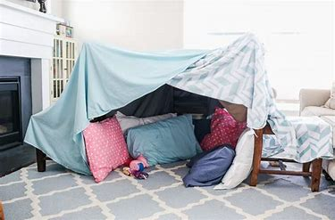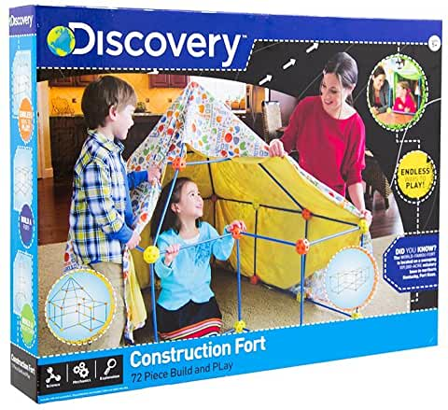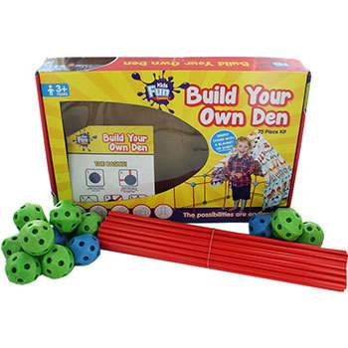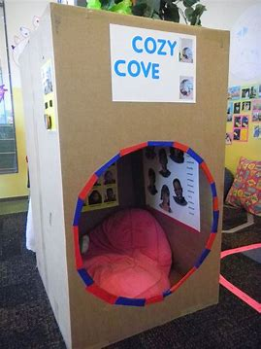

https://www.amazon.co.uk/TheWorks-Build-Your-Own-Den/dp/B01FNRD3XA/ref=sr_1_1?dchild=1&keywords=build+you+own+den%2Ffort+kit&qid=1588532774&sr=8-1

Crawling through tunnels:

Materials needed: Boxes (if have), blankets, chairs

Steps to play:
Build an obstacle course indoors for your child to follow. Some ideas can be:
● place cushions to jump from one cushion to the other.
● open up both ends of a box to crawl through.
● place a sheet over two pieces of furniture e.g. sofa and footstool, to make a
homemade tunnel to crawl through.
● place chairs in a row with sheets over the top to crawl through.
● crawling under a table or even under the legs of chairs.
● open up both sides of the den to crawl through the den.

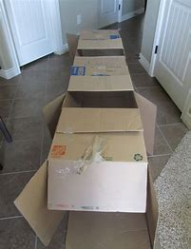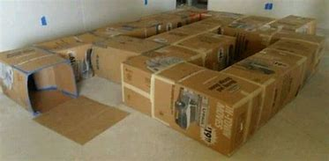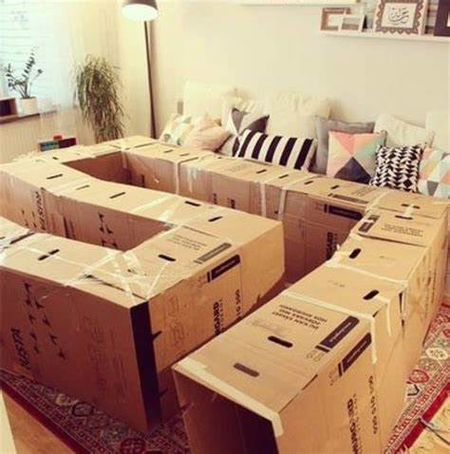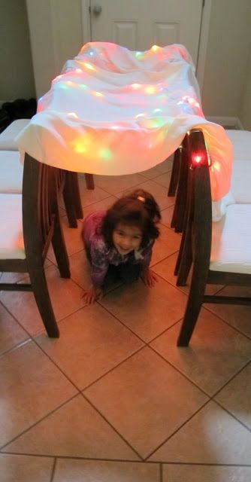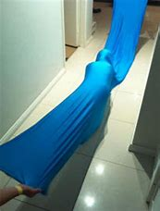
You make a lycra tunnel as well which adds increase resistance.
https://www.amazon.co.uk/Lycra-Sensory-Integration-Play-Tunnel/dp/B00STF6430/ref=sr_1_1?dchild=1&keywords=lycra+tunnel&qid=1588533626&sr=8-1

The deep pressure input in the body (from crawling) will help calm and focus the child.

Tactile stimulation:
Sensory bags:

Materials needed: Zip-lock food bag, tape, hair gel and small plastic animals
e.g. jumping frogs.

Steps to play:
Preparation:
● Put the hair gel inside the bag.
● Put the small plastic animals inside the bag.
● Let all the air out of the bag by pressing lightly on the bag, before
sealing/closing it.
● Use tape (Sellotape) to seal up the bag opening, to prevent leakages.
Play: http://plainvanillamom.com/2012/04/sensory-bag-for-baby.html
● Your child can explore it by squeezing, rubbing and touching the bag, without
their hands getting messy. You can also stick the bag to the window with tape,
to let the light through.

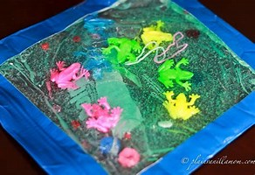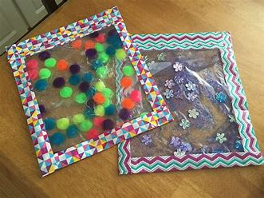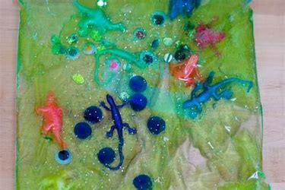

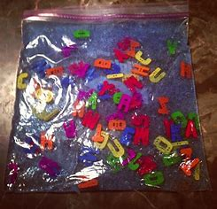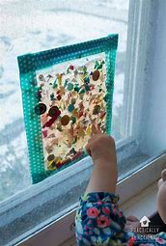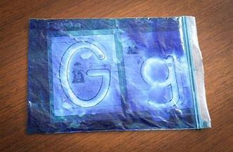

Dry textured play :
Materials needed: 1 cup of plain rice, food colouring, 1tsp vinegar, food storage bag or empty yogurt container

Steps to play:
Preparation: https://happyhooligans.ca/rainbow-rice/
● Place rice in the bag or container.
● Place a few drops of food colouring on rice.
● Place 1 teaspoon of vinegar on rice (to keep hands from staining).
● Close the bag or container and shake. You will notice the rice changing colour.

● Spread the rice on a plate to dry. You might need to leave overnight to dry.
● When dry, store in a closed bag/container, to reuse.
Play: http://twinmomrefreshed.com/easter-sensory-bins-for-toddlers/
● Use the plain or coloured rice for sensory play.
● Place the coloured rice in a large container with cups and spoons.
● Show your child to scoop and pour. You can also add their favorite toys
within to play.

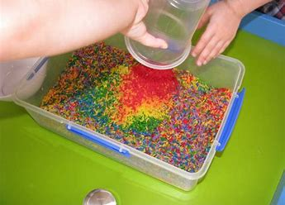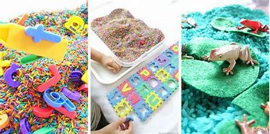
● Extra ideas:
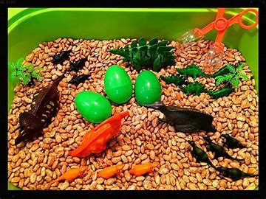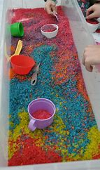

Messy play:
Materials needed: Shaving foam, coloured straws cut into pieces, tray or plate.

Steps to play:
● Spread shaving foam on the tray.
● Draw shapes, numbers or letters in the shaving foam, for your child to copy.
● Can they draw a picture? Draw a car or a man.
● Spread out shaving foam again on the tray. Push Cars through foam.
● Let your child copy you to build a rainbow with straws in the foam.

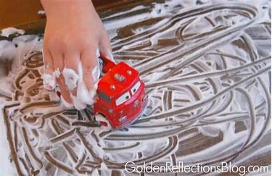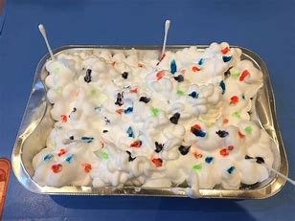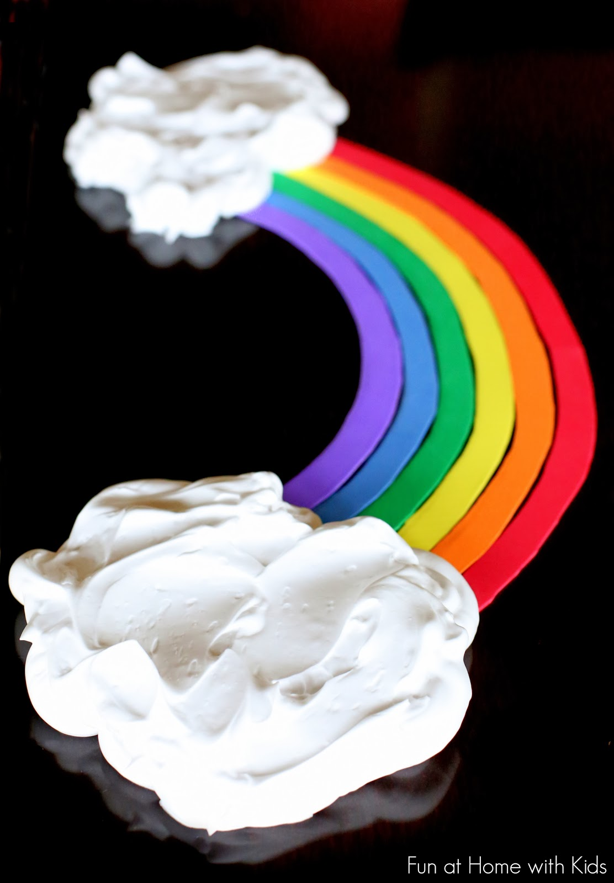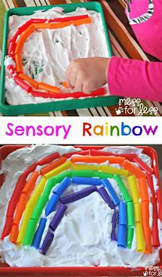

Messy play with food :
Materials needed: Plain yogurt, food colouring, small bowls (empty small yogurt containers),celery or carrot sticks (optional)

Steps to play:
Preparation:
● Place plain yogurt in each small container.
● Place a few drops of food colouring in yogurt.
● A different colour in each container. Stir.
● Cut a piece of carrot or celery into 5cm pieces.

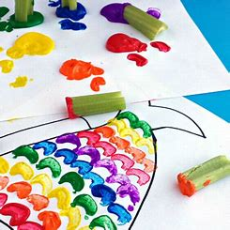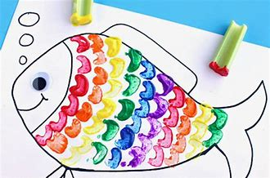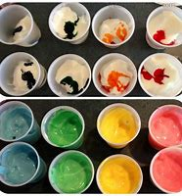

Play:
● Use a piece of colouring in paper or draw a picture such as a fish.
● The child presses the celery stick in the yogurt ‘paint’ and then on the picture to paint the picture. They can also use their fingers to finger paint on the picture.
● Leave to dry.

As this is edible, they can place it in the mouth without concern.

Oral motor:
Blow bubbles:

Materials needed: Bubbles
Steps to play:
● Blow bubbles.
● The child pops them by touching it with their finger or clapping their hands.
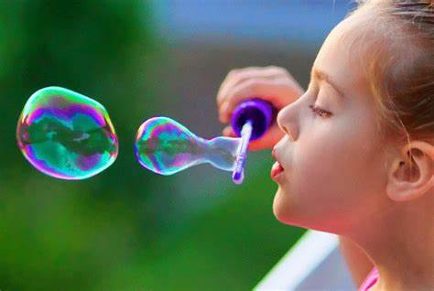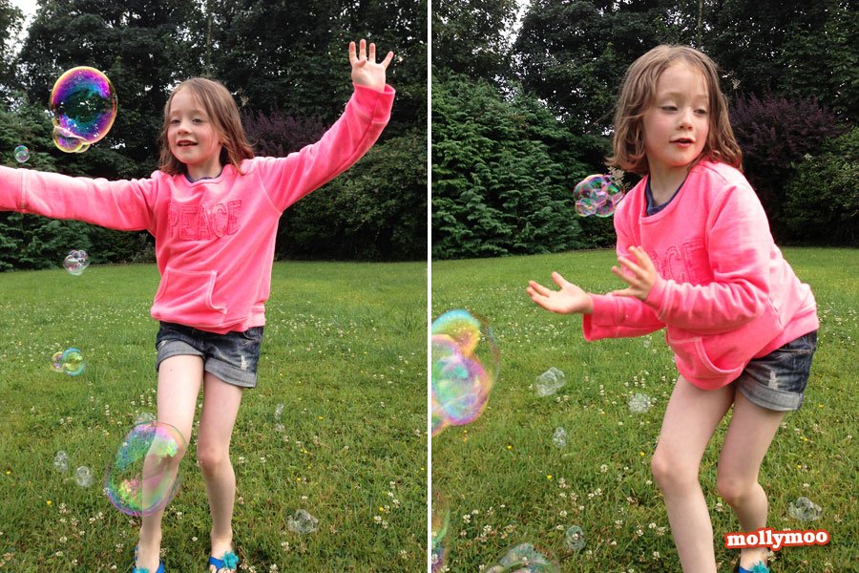

Drink pudding or applesauce through a straw:
Materials needed: Thick liquid such as chocolate mousse or puree, short straw
Steps to play:
● Place straw inside the pudding pot.
● The child drinks the thick liquid through straw. The wider the straw, the easier.
● (Sucking can be very calming and organising.)

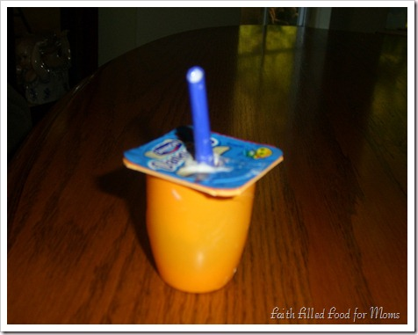

Blowing party whistles :
Materials needed: Any small party whistles or blowers
Steps to play:
Provide your child with party whistles or blowers to blow. 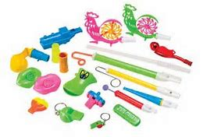
Blow cotton balls across the table with a straw :

Materials needed: Cotton balls and straws

Steps to play:
● First try to blow the cotton ball with your mouth across the table or
through a maze built by blocks or boxes. (without straw)
● Try blowing the cotton ball across the table with a straw.
● Also try: Blowing the cotton ball to a target.

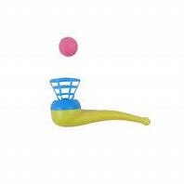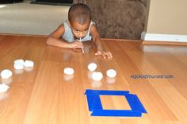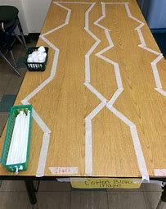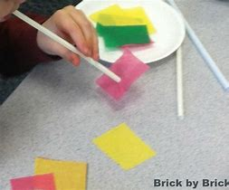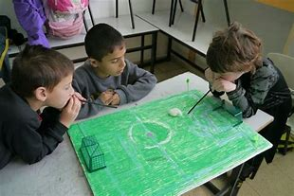

Auditory:
Activity belt :
Materials needed: Belt (preferably with holes), keyrings and string, different smaller everyday objects of interest e.g. bells and keys (noisy), brushes (tactile/feely), chewy or rubber toys for chewing.

Steps to play:
● For certain children who are very active and/or reluctant to sit still and explore objects, an activity belt works well. Especially when they are ‘forced’ to site. e.g. long rides in a car or buggy.
● Attach the objects with keyrings and string to a belt.
● Buckle the belt in the back so the child cannot easily remove it.

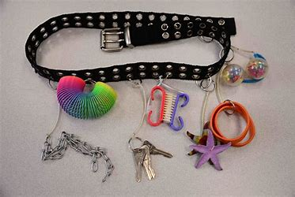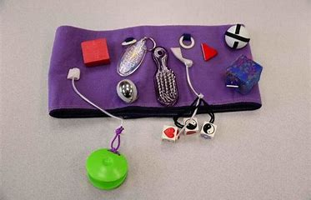

Musical Shakers :
Materials needed: Empty plastic water bottle with lid, screwdriver, ribbons,
handful of plain rice, pompoms (You can use anything colourful e.g. rice,
buttons, pasta; even sticks and rocks)

Steps to play:
Preparation:
● Make a hole in the bottle lid with the screwdriver.
● Feed the end of the ribbons through the hole and tie a knot on the inside of
the lid.
● Place the pompoms (or other objects to make a noise) inside of the bottle.
● Tightly close the lid.

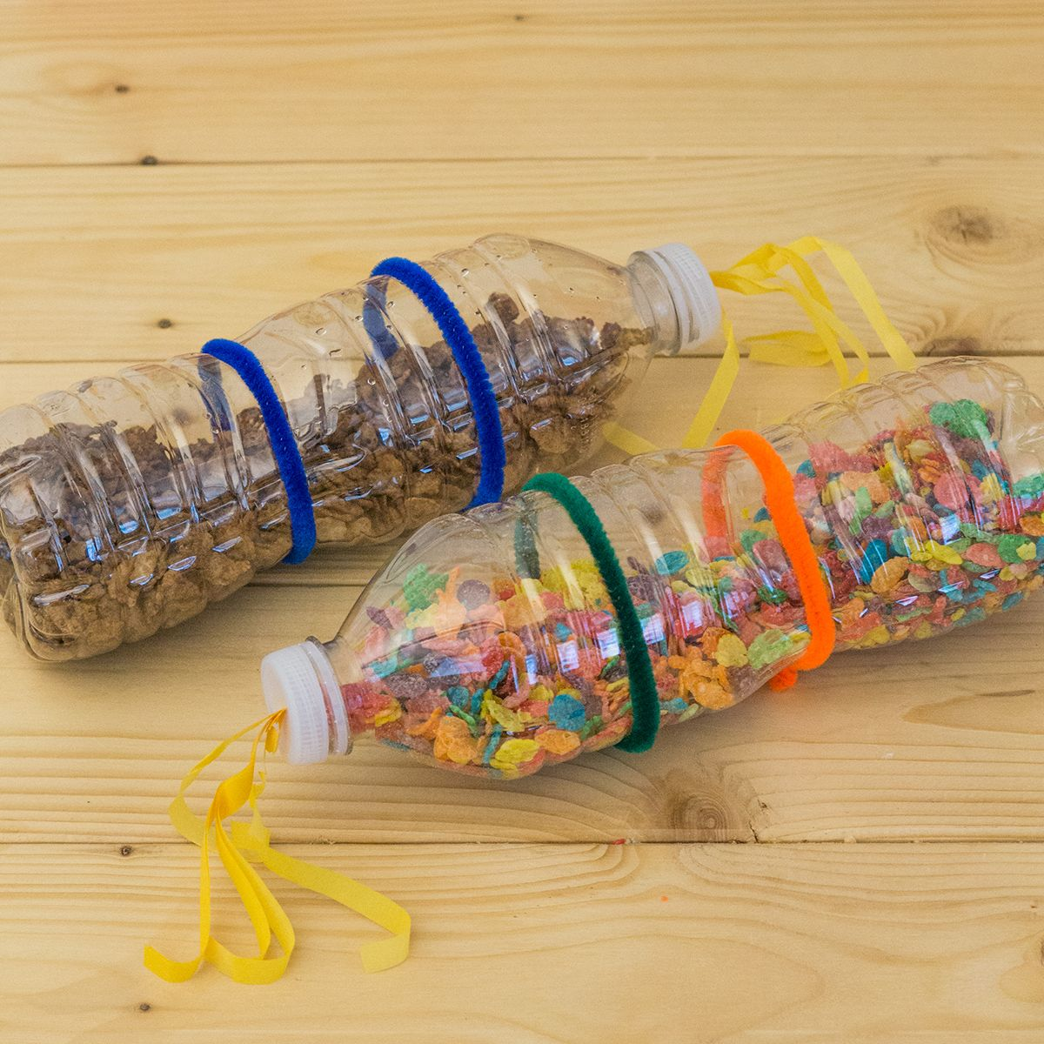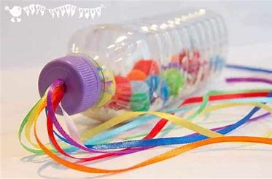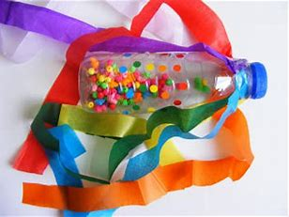

Play:
● Your child can use this as a shaker, to make music.
● If you shake your shaker in a pattern, can they copy you; taking
turns?
● Let’s shake with their favorite music playing.

Taxing noises for noise sensitivities :
Taxing noises: Use an easy-to-use recorder such as a microphone app. Record sounds that your child is sensitive to or cannot tolerate. Play the sounds back throughout the day at a reduced volume as a way of desensitizing.

Apps :
Peeping Musicians: https://apps.apple.com/gb/app/peeping-musicians/id490120210 (£2.99)

Has been designed to encourage early looking/observation skills and develop
basic touch and targeting skills. Wait and watch for the musician as they ‘peep’
from the top, bottom or side of the screen. Simply touch them to make them move centre stage and play a piece of music. There are 20 different characters and instruments to find.

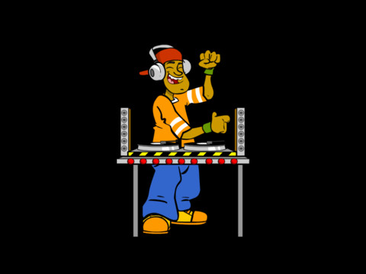

Proprioceptive/calming:
Towelling: Put lots of cream on your child’s hand and forearm. Firmly massage the forearm and hand; then rub it with a dry face cloth in the direction from the elbow to the fingertips. If this is done firmly, it gives a deep pressure feeling; which can be quite calming.

Stress ball squeezing :
Materials needed: medium/large balloons, funnel, filling (If you do not have a funnel, cut an water bottle in half and use the mouthpiece as a funnel)
Choosing the filling: For a typical pal-sized stress ball, you’ll need about 160 to 240grams of filling (5cm to 7.5cm deep). Any would do:
● Firm stress ball: use flour or cornflour
● For looser stress ball: use dry rice, lentils, small beans or even play sand
● Super squishy ball: use slime, hand wash gel or hair gel
● Mix a small amount of dried rice into flour for something in between. This is more durable than flour alone.

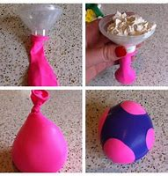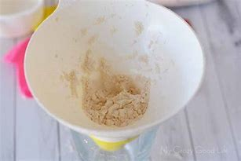

Steps to make:
● Stick a funnel into the neck of the balloon.
● Fill the balloon slowly to avoid clogging the neck of the balloon. If it
clogs, use a spoon handle to clear the opening.
● When done, take out the funnel and let out as much air as you can.
● Pinch out all excess air and tie the neck of the balloon closed tightly.
● Use a sharp scissor to cut off the dangling end of the balloon. Don’t try to cut too close to the knot, or it could come undone.

● Cut another colour balloon as pictured above. Pull it over your first balloon to hide the knot and make it stronger.

Bouncing on the gym ball:
Materials needed: Gym ball (can be bought from supermarket sports department oramazon) Also: https://www.sensorydirect.com/anti-burst-therapy-ball.html 40cm or 50cm.

Steps to play:
● Make sure all furniture is moved away, for your child’s safety.
● Your child sits on the therapy ball, while you support them initially at the hips
with your hands.
● Slowly bounce them up and down, while counting from 1 to 10 or singing a
song.
● As they get used to this activity, the child would be able to maintain their own
balance in sitting on the ball. If they do not have balance, then keep
supporting them at the hips.

Laying over the gym ball on tummy:

Materials needed: Gym ball 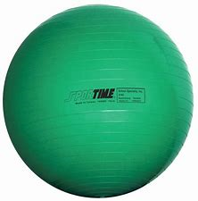

Steps to play:
● Make sure all furniture is moved away, for your child’s safety.
● Let your child lay over the gym ball on their tummy, with their hands placed on the floor in front of them. Place your hands on their hips, to support them from rolling off the ball.

● Can they move forward by ‘walking’ on their hands?
● Can they keep their balance for one or two minutes?
● Extras: If they can balance on the ball, place a toy or game in front of
them to do with one of their hands, while the other hand supports them
on the floor. Any toy will do. Inset puzzles, fine motor activities or even
playdough works well.

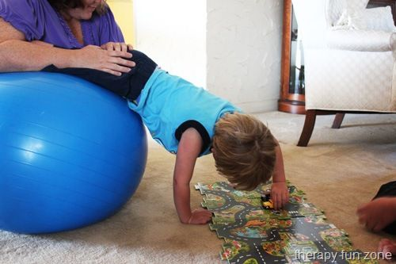
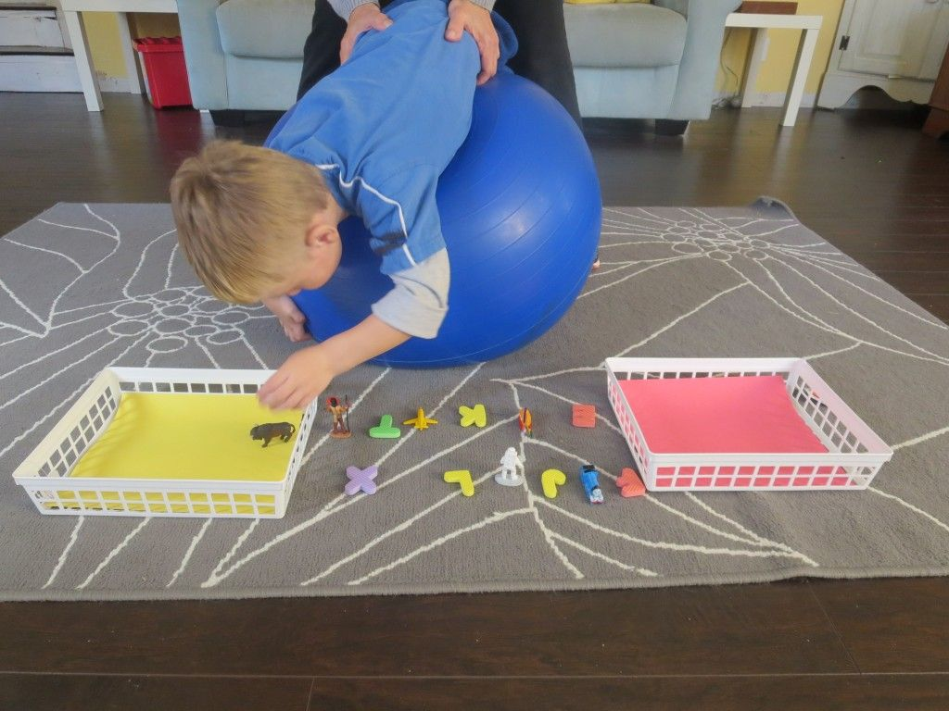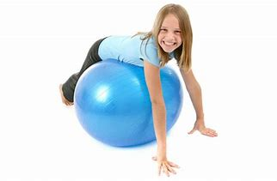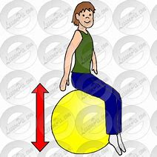

● Also try: Let your child lay on their tummy on the carpet. Roll the ball up and down their body with pressure. The pressure on their body is calming.

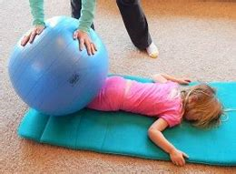

Jumping on a trampet/trampoline.

Materials needed: Trampoline or trampet

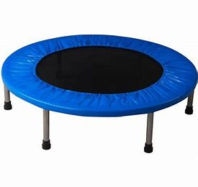
Steps to play: Your child will find great benefit, if they have access to a trampoline in the back garden or a trampet indoors. Jumping on the trampoline
will get rid of all the excess energy they have, helping them to self-regulation.

Visual motor skills:
Toy road:

Materials needed: Masking tape, blocks and cars (vehicles)

Steps to play:
Preparation:
● To set up use masking tape to tape a ‘road’ on the floor. Place blocks or even recycling plastic containers cut into tunnels over the road. Place trains and cars on the road.
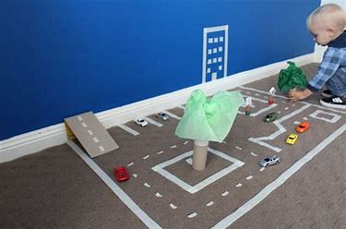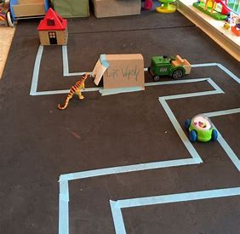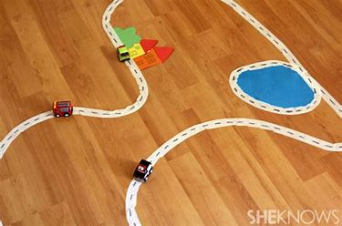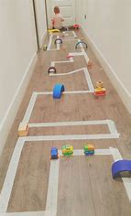

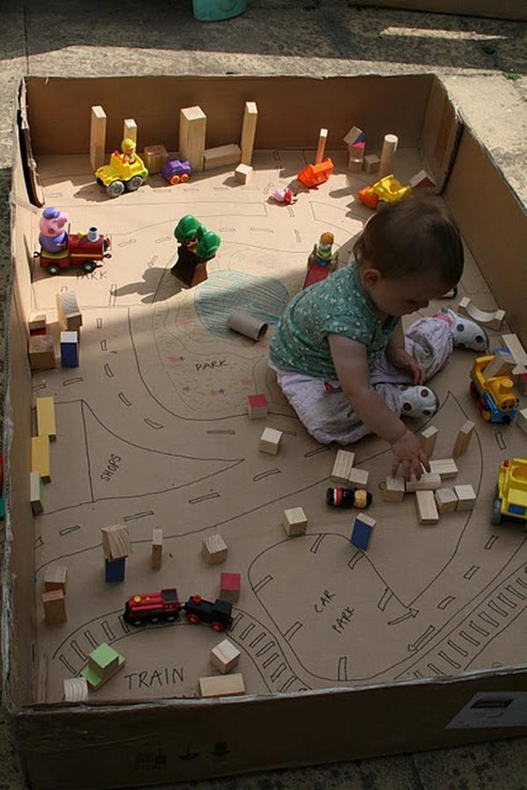

Play:
● Encourage your child to push the vehicles along the road.

Calming bottle:
Materials needed: Empty water bottle with lid, water, food colouring, fillings such as pompoms, buttons, pasta, beads, glitter etc.

Steps to make:
● Decide on which filling you want to use e.g. glitter and beads, with a few pompoms. Add a few of your filling in the bottom of your bottle.
● Fill the bottle up with water to the top.
● Add a few drops of food colouring to add colour.
● Tightly fasten the lid of the bottle. You can even tape the bottle lid, if you are concerned your child will unscrew it.

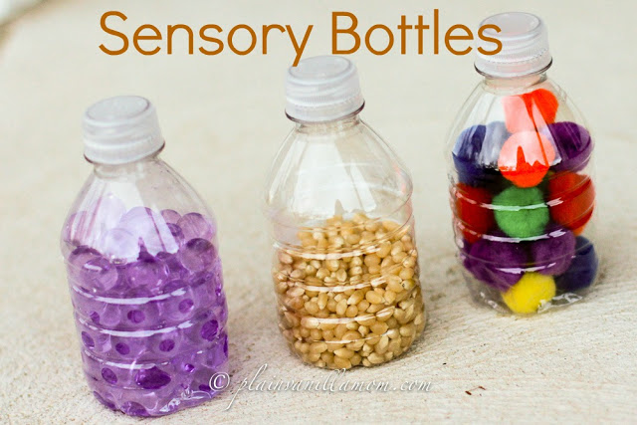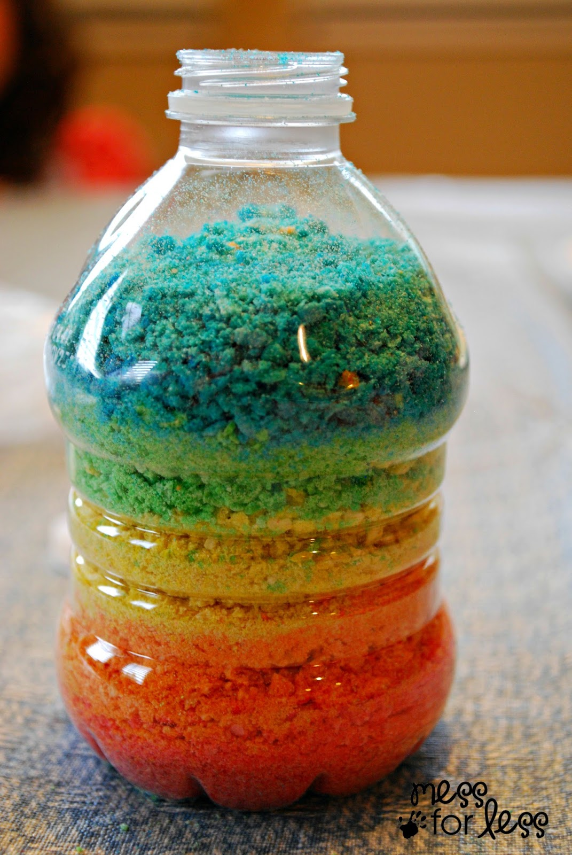

Alternatives:
● Some children enjoy watching the water splash, thus leaving a space at the top (2 cm) for the water to move back and forth.
● By adding hair gel instead of water, you will change the consistency of the bottle, with a slower flow of objects.
● Let your child fill the bottle with fillings and do not add any liquid. Fasten the lid when they finish, to make a shaker.
● Give the bottle to your child to play with.

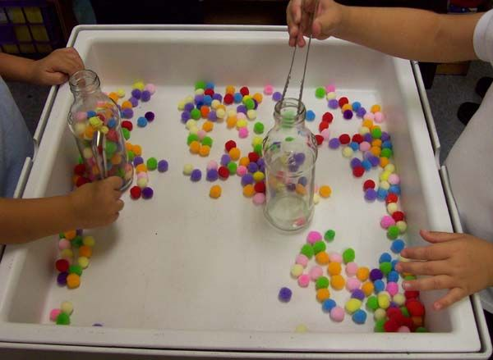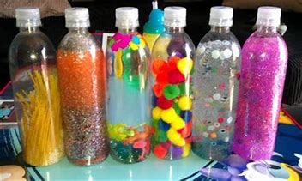

String light :

(Please note that this can be overstimulating for some of our kids.)
Materials needed: string lights or Christmas lights and large box
How to make:

● Press holes in the top of the box with ascrewdriver. Insert the lights from the top of the box into the holes.
● You might want to cover the top of the box, if you are concerned
that your child or siblings might fiddle with the wires.

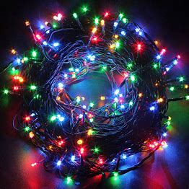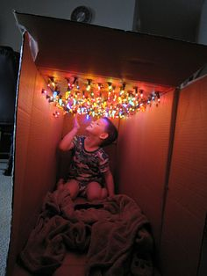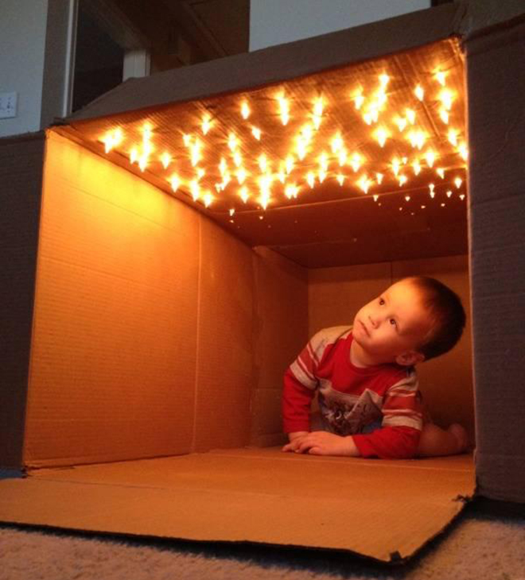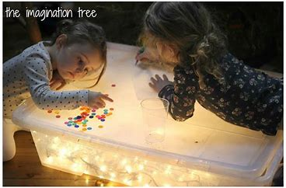

Please do not leave unsupervised or unattended.
Apps: https://apps.apple.com/us/app/friskies-jitterbug/id468857054
Catch the bugs.
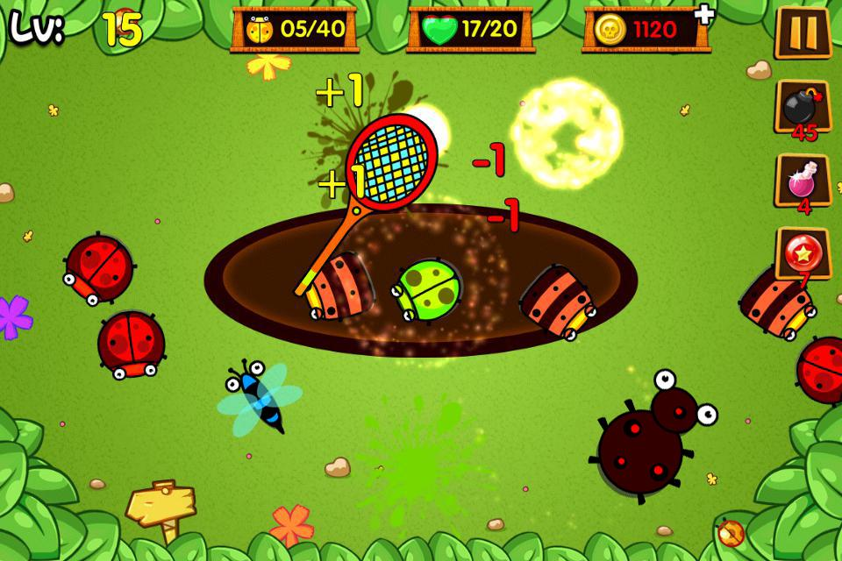

Fine motor skills:
Taped Toys:

Materials needed: Small toys, tape (sellotape or masking tape)

Steps to play:
Preparation:
● Use small pieces of tape to tape the animals to a surface.

Play:
● The child needs to take the tape off to rescue the animals.

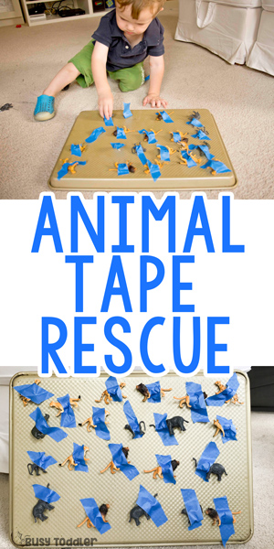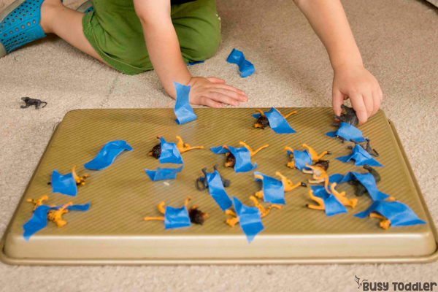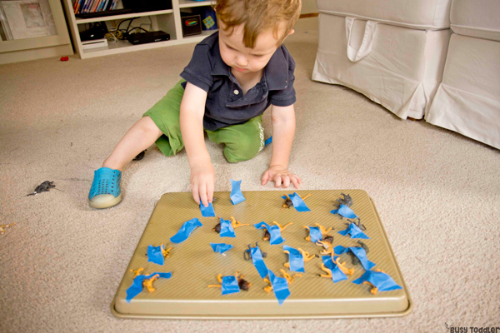

Drive and drop :

Materials needed: Box, scissors (or box cutters), vehicles (cars)
Steps to play:

Preparation:
● Cut a rectangular slot in the top of the box.
● Draw or tape out lines for roads.

Play:
● Place the cars on the side of the box and invite your child to play.
What is in the box? :
Materials needed: Box, scissors (or box cutters) and toys.
Steps to play:

Preparation:
● Cut round slots on top and sides of the box. Make sure they are of different
sizes and larger than the toys, for easy access.

Play:
● Place a few toys, which fits easily within the holes, on top of the box.
● Invite your child to post them in … and take them out.
● (There need to be a few holes big enough to fit your child’s hand with a toy.)
● Grading: If it is tricky, use less holes and toys, even just one toy; with larger holes.

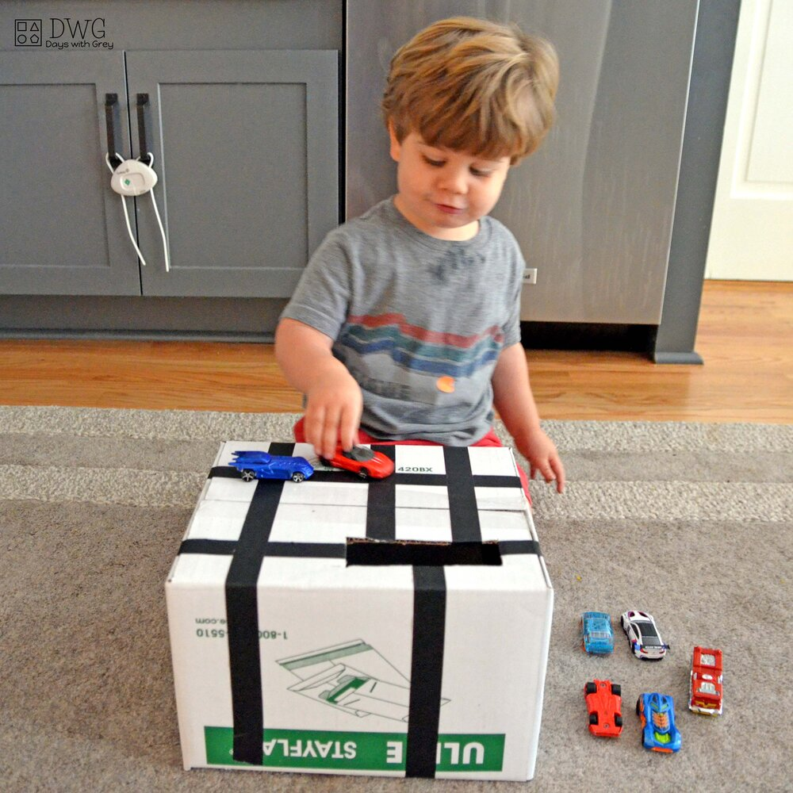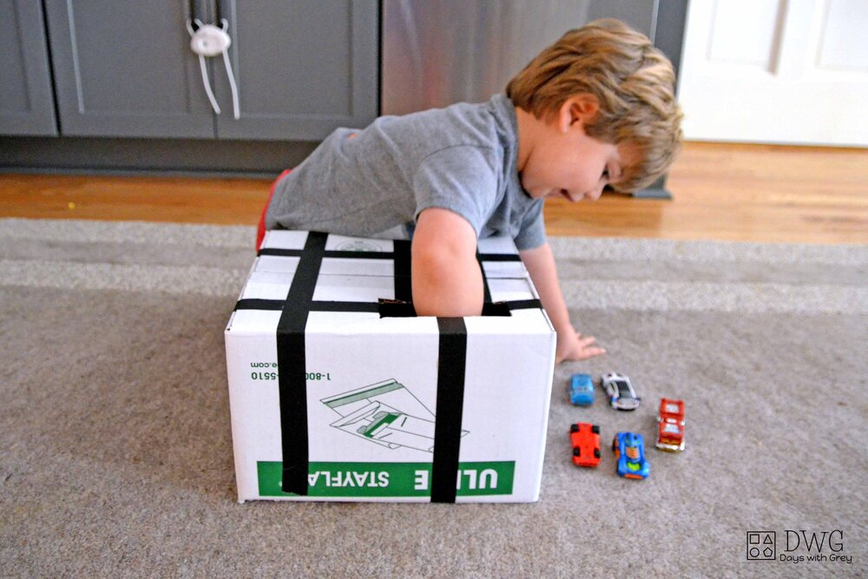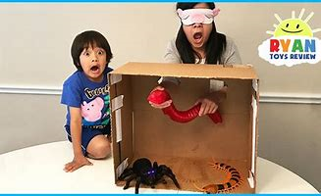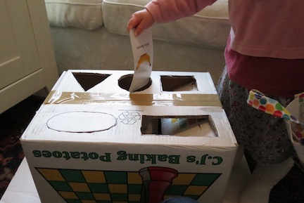

Put in milk lid :
Materials needed: Large container e.g. yogurt or coffee container with lid, small lids such as milk lid.

Steps to play:

Preparation:
● Cut a rectangular slot in the lid of the large container, for the milk lids

Play:
● Encourage your child to post the milk lids within the hole.
● If they find it difficult: take the larger lid off and show them to put the milk lids
one by one in the container.
● Replace the larger lid and start posting it again through the small hole or change hole to a larger circular hole.

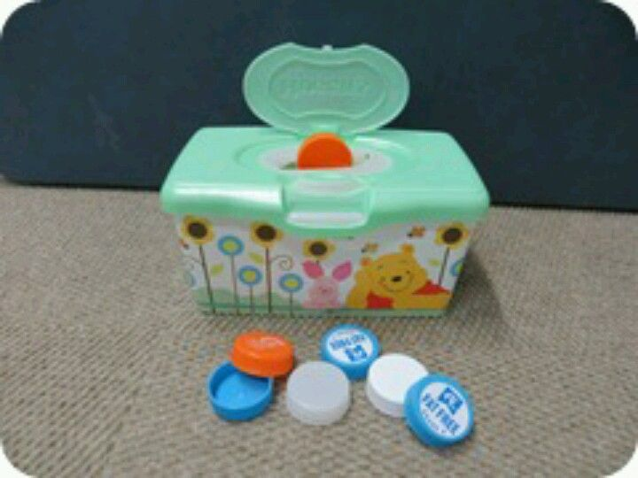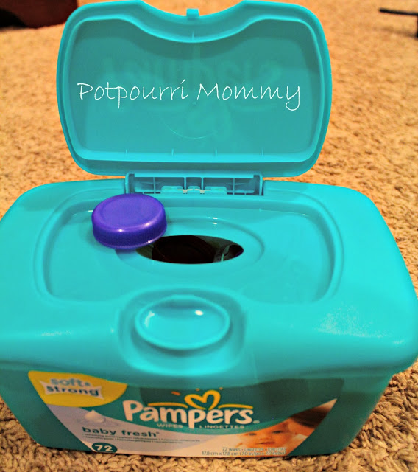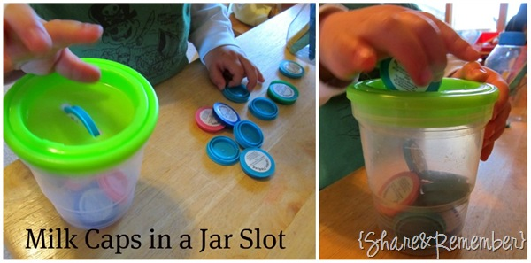

Please do not hesitate to contact me if you require any further advice or have any questions.

Kind regards
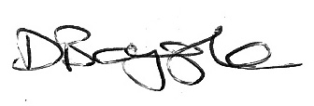
Signed:

04.05.2020
Donna Boygle
Advanced Sensory Integration Practitioner
Occupational Therapist
College of Occupational Therapist Membership Number: BT0226432
Health Professional Council Registration Number: OT45336

